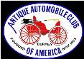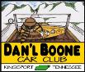
DAN’L BOONE REGION CAR CLUB
President Howard Irwin 423- 530-6027
Vice President Don Wood 423-929-3299
Secretary Randy Still 423-245-4000
Treasurer William Anderson 386-795-2254 Sunshine David Williams 423-765-1095 Newsletter Editor Frankie S. Lambert 423-534-3358
Allandale Chair David Williams 423-765-1095 Board of Directors Marty Lane (Chairman) 423-557-4159 Fred Counts, Howard Osborne, Tom Wright
XLVI January 2024
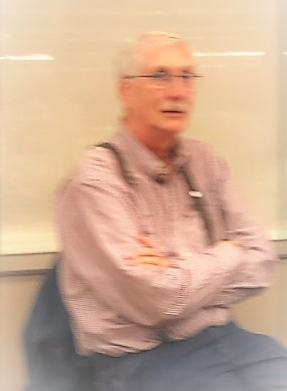

From the desk of Howard Irwin, club president
Happy New Year Dan’l Boone Club!
Hoping this finds you all just having celebrated at very Merry Christmas for 2023 and looking forward to a great 2024! Thanks to Marty for leading us thru a fun 2023 and I look forward to his help and support as he has moved on to be our Board Chair for 2024. Also, thanks to all the 2023 officers and board members and a special thanks go to Wayne for his years of service as Club Treasurer. Thanks to Randy and Don for coming out of retirement to again be active as officers for 2024.
Our Dan’l Boone Club capped off the year with a fun Christmas dinner. We all enjoyed the meal and gifts afterwards. We welcomed new members, Brian & Miranda Dean, for their first meeting with us. Brian actually helped Dave Williams with the Allendale show music. Some photos of the evening are included below. Also, recently joining us from the Bristol area are Susan & David Taylor and Pat Ball.
Several things I’d like to mention as we move into January. Firstly, our meeting place has changed. Our December meeting was the last meeting at Guiseppie’s as they are closing on the first of the year and their reopening is uncertain at this writing. We will meet January on the 16th at 6pm at the Meadow View Resort in Kingsport. They have shown us a sincere interest in having us meet at their facility. Please plan to attend. We’ll use this meeting to talk about activities for 2024 and hopefully get some feedback from you about our proposed plans. Secondly, I’d like our Club to focus on two things as we move into 2024. I’d like to continue and expand what I call the “Fun & Fellowship” side of our Club and to “Grow” our membership. We’ve got a great and diverse group of Club members and I always enjoy being with you all, especially if it involves our common interest, cars (and eating too). We live in an area where there are many other folks with similar interests who we could connect with and bring into our Club. We’ll talk more about this at the January meeting.
To give you all and idea of some of the Club events we’d like to consider for 2024, in addition to our regular monthly meetings and Sonic Last Friday night Cruise Ins, I’m listing these ideas by month below for Fun & Fellowship that can hopefully help us Grow.
- April: Consider a short “Springtime Cruise thru the mountains” that would be a Saturday event ending with lunch together at a local restaurant
- June: Dave Williams is working up a cruise/show for a local Senior/Assisted Living facility
- July: Our annual Fun Fest Car show and show at Nottingham UMC
- August: Consider a cruise to Bristol Hot August Nights and dinner downtown, another cruise to Doe River Gorge with train ride and lunch together, also a cruise to Axe Handle Car show.
- September: Allendale!
- October: Cruise to Cranberry Festival in Shady Valley
- November: Cruise to Veterans Day Show at the VA Hospital, including hot dogs & hamburgers
Again, let’s have a great 2024 together and I’m looking forward to seeing you all on the 16th!
Howard
December Meeting of Dan’l Boone Region Antique Car Club Minutes

25 gathered at Giuseppe’s on Tuesday, December 18th. We welcomed guests, Bryan and Miranda Dean. They drove their 1965 Chevrolet. Bryan helped with our music at the Allandale Show in September.

President, Marty Lane asked Bill Anderson to have the invocation. After dinner, Marty led the Pledge of Allegiance then began the meeting. Marty called on Wayne Lambert for the treasurer’s report, which was accepted. Marty thanked Wayne for his years of service as treasurer. Dave Williams gave the sunshine and shadows report. Howard Osborne was awaiting spine surgery for sciatic pain. Sergio Merluzzi was starting treatment for prostate cancer and Sharon is dealing with leukemia.
Dave Williams read the nominated slate of officers for 2024.
President: Howard Irwin
Vice President: Don Wood
Treasurer: Bill Anderson
Secretary: Randy Still
New Board Member: Fred Counts

The slate of nominations was accepted by acclamation. Dave Williams thanked each officer for their work in 2023 and issued framed certificates of appreciation. He also recognized Gary Head for his work on the Allandale Corvette Display and Scott and Sandy Mathein for bringing their 1907 Cadillac to all Region Shows.

Howard Irwin then gave personal gifts to each outgoing officer. The meeting was concluded with door prizes awarded by Dave Williams. The meeting was then adjourned.

Respectfully submitted,
Randy Still, Secretary
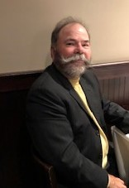

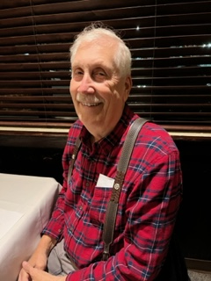
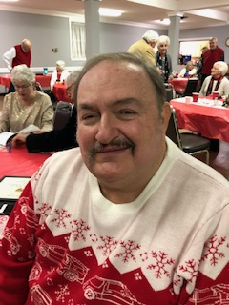
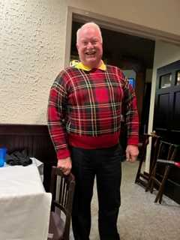
Secretary
Randy Still

Christmas Celebration Photographs continue

President
Howard Irwin
Secretary
Randy Still
Vice President
Don Wood

Treasurer
William Anderson

Remember to Pay your local dues
$15 for a single and $20 for a Couple
YOU may mail dues; to
William Anderson, Treasurer
Birdsong Lodge 3204 Highway 91
Shady Valley, TN 37688
He will not be attending the January Meeting

Sunshine from Dave Williams
Greetings! Continue prayers for Sergio Merluzzi who is undergoing
radiation treatment five times weekly and chemotherapy once weekly.

At last report Howard Osborne is having PT following back surgery in
December and is well on the road to recovery.

Please let me know if you have member information whether it is
sunshine or shadows.

Christmas Celebration Photographs-
Howard Irwin, Frankie Lambert and Randy Still
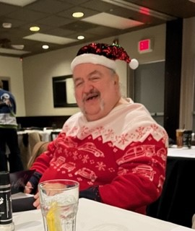
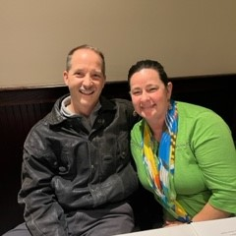
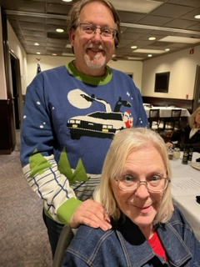

Say HI to the Deans, New
Members to the club.

Past President Marty Lane and his wife Debbey Lane. Marty will now be Chair of the Dan’l Boone Region Board. He is also the Web Master.

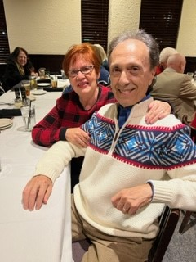
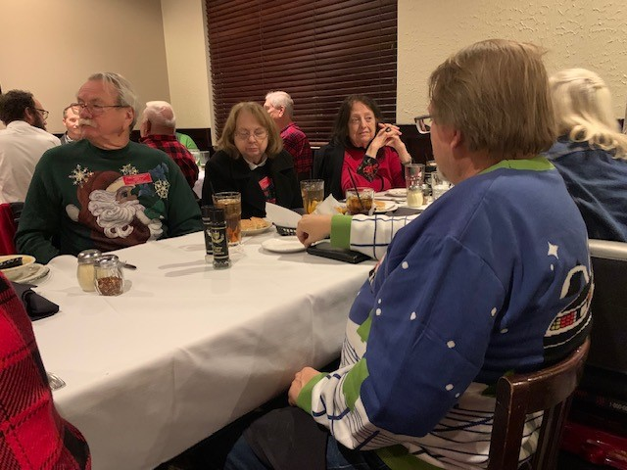

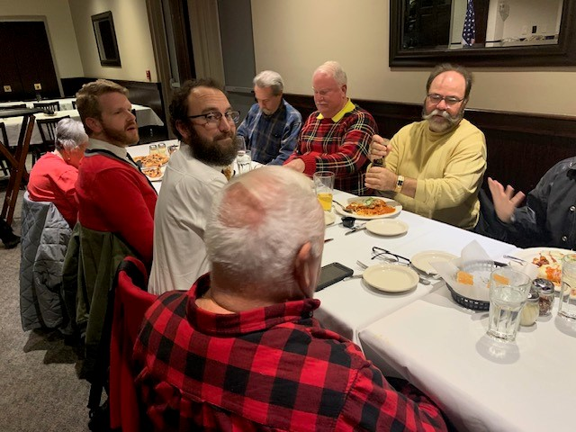

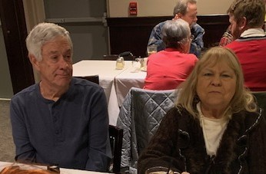

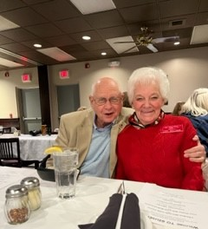
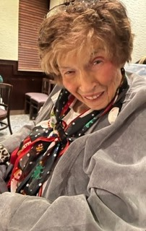

Drive safely
safely
s
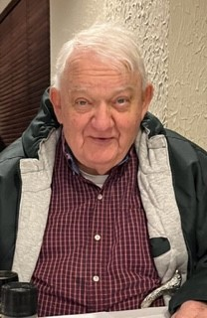
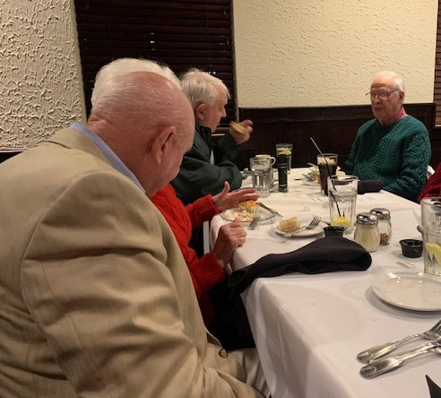
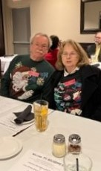

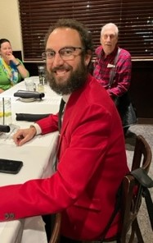
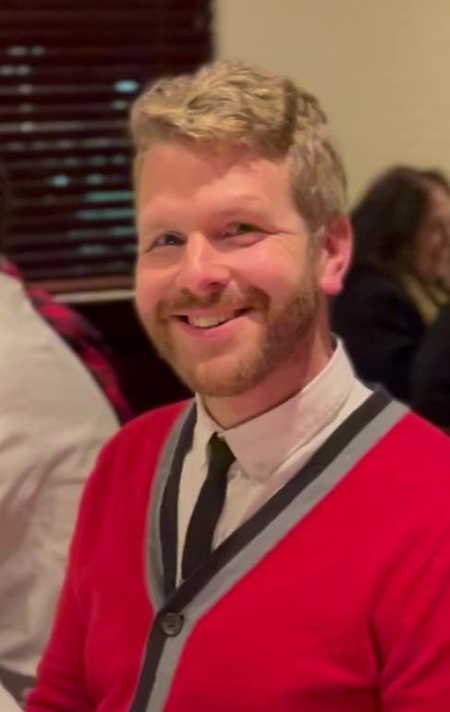

Find your Renewal Form for 2024 in November or December of The Antique Automobile Club of America .
These are your AACA National Dues- For $45. The amount is for you or you and your spouse.

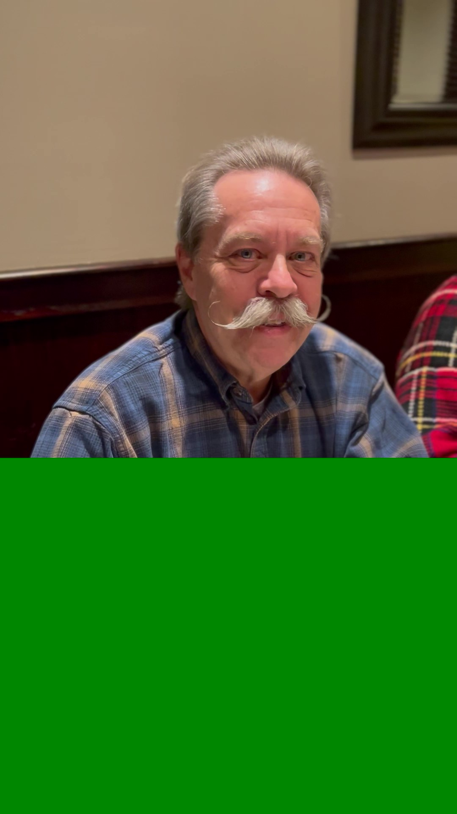

HAPPY NEW YEAR

