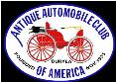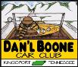
DAN’L BOONE REGION CAR CLUB
President Marty Lane 423-557-4159
Vice President Howard Irwin 423-530-6027
Secretary Sharon Williams 210-544-8583
Treasurer Wayne Lambert 423-276-3741 Sunshine David Williams 423-765-1095 Newsletter Editor Frankie S. Lambert 423-534-3358
Allandale Chair David Williams 423-765-1095 Board of Directors Randy Still (Chairman), 423-245-4000 Sergio Merluzzi, Howard Osborne, Tom Wright
XLV November 2023
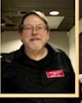
From the desk of President Marty Lane

Greetings Car Aficionados,
With a chill in the air, we are kicking off Fall with some great memories and yet a few remaining auto events for us to enjoy before winter sets in.
The TRUNK OR TREAT car show downtown at the Kingsport Farmers Market was on Friday Oct 27th from 5-9:30 pm sponsored by Speed line Automotive Sales LLC. This was the 2nd annual trunk or treat show where hot rods, muscle cars and classic cars and trucks handed out candy to all the kids and helped to foster a new generation of car lovers.
The Classic Car Show for the Veterans was on Thursday, November 9th at the VA in Johnson City. The weather was excellent and a modest turnout for this show's first year made for some good classic car viewing and good hamburgers and hot dogs on the house. Our Daniel Boone Region club members had good representation present at this show. Dave Williams, Gary Head, Matt Caldwell, Fred Counts, Tom and Betty Wright, Marty and Debbey Lane, Don Woods, Howard Irwin and Scott Mathein were all there for the festivities. I hope I didn't leave anyone out.
Special Thanks goes to Dave Williams for helping those folks with getting the word out for this first year event and thanks to Howard Irwin for organizing a club caravan to the show, providing maps and directions via email and the general promotion of the event as well.
Well wishes to The Veterans at the VA who had a strong turnout and enjoyed the cars and fellowship. We owe those folks a great debt indeed.
Our next car club dinner will be at Guiseppe's on Tuesday, November 21st at 6pm and as an early reminder, our Christmas Dinner will be at Guiseppe's on Tuesday, December 19th at 6pm.

As always, I look forward to your participation and seeing you at our club events.
Happy Motoring!
Marty Lane
President, Daniel Boone Chapter AACA

Dan’l Boone Region Antique Car Club Minutes from October 17,2023
21 members and 2 guests in attendances
President Marty Lane called the meeting to order and led the Pledge. Bill Anderson offered the prayer.
Wayne Lambert gave the Treasurer’s Report for September 2023. The ending balance for September was $12,987.65.
Howard Irwin gave a presentation on the drive to Shady Valley for the Cranberry Festival.
Randy Still showed pics from the AACA National Meet in Hershey, PA.
Gary Head had received an AACA 1st Junior on his 1991 Corvette and so did Randy Still on the late Tom Hughes' 1973 Cadillac.
Plans were discussed for the trip to the VA in Johnson City on Thursday, Nov. 9th.
The meeting ended.
Submitted by Frankie Lambert and with a little help from a friend.

Photos Provided by Randy Still from Concours at Chattanooga
Ferrari Exhibit at Chattanooga Concours
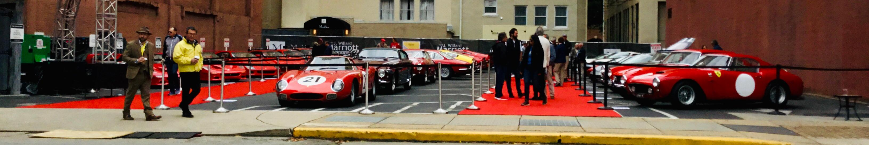

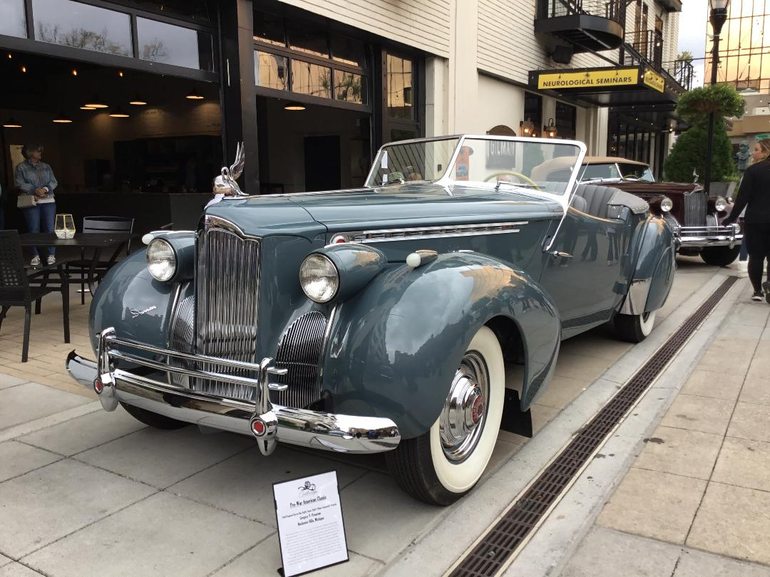
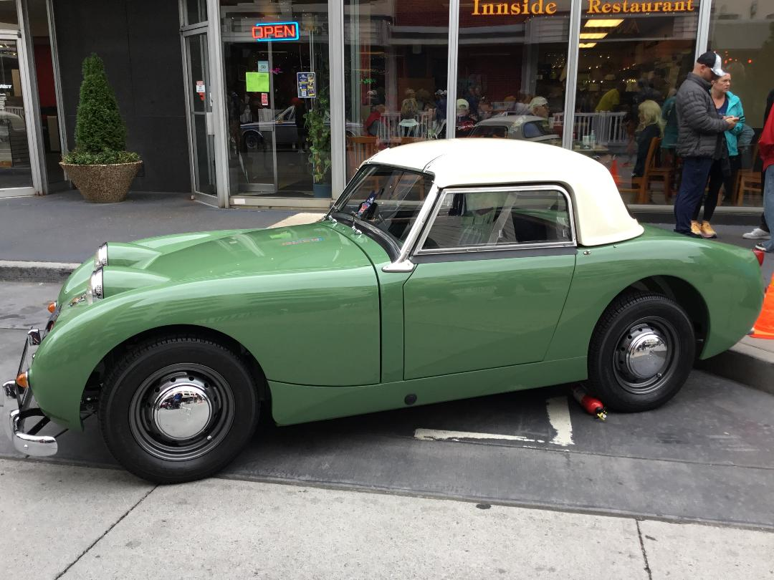
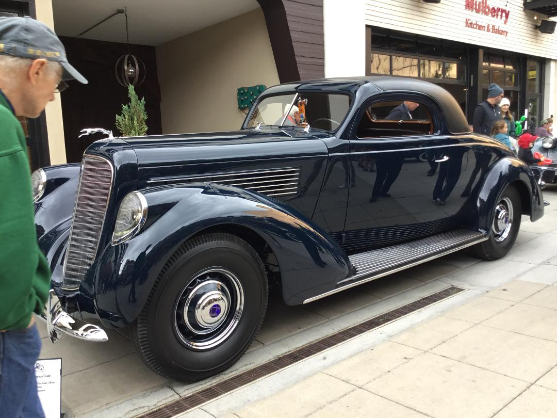

1941 Packard Darrin 180 Convertible/ Wayne Carina’s Lincoln K Coupeat Austin Healey Sprite Chattanooga Concours
Austin Healey Sprite Chattanooga Concours Wayne carinii’s Lincoln K Coupeat

/
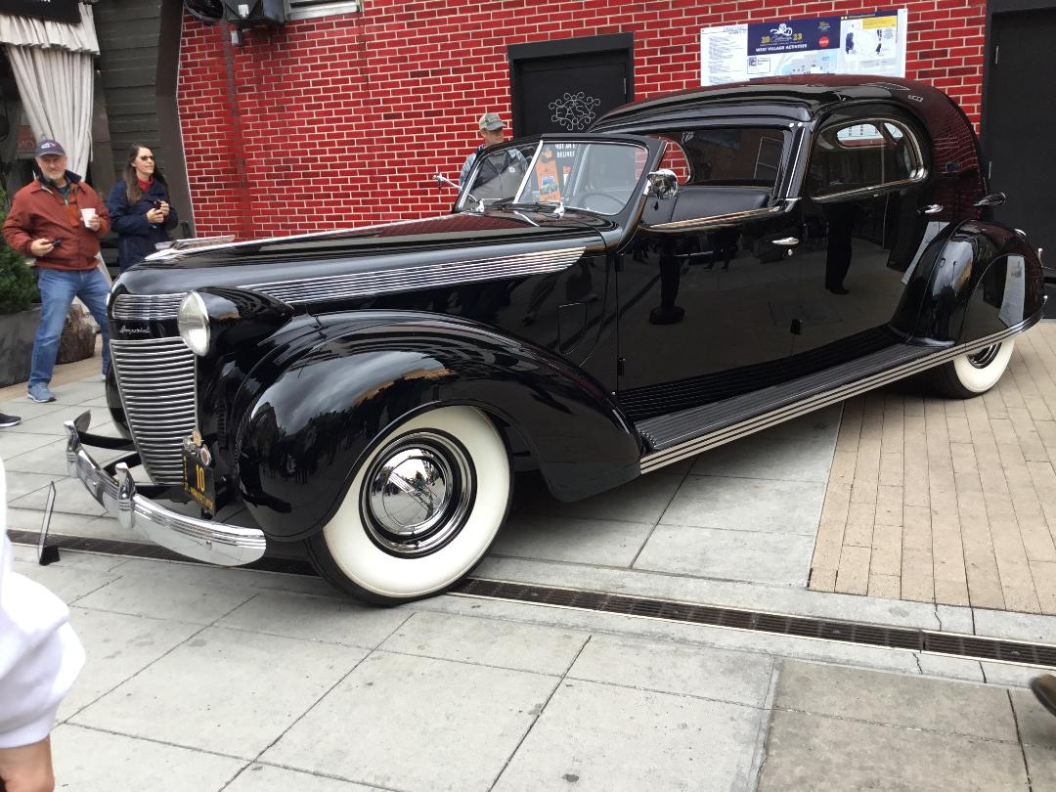
Pierce Arrow Silver Arrow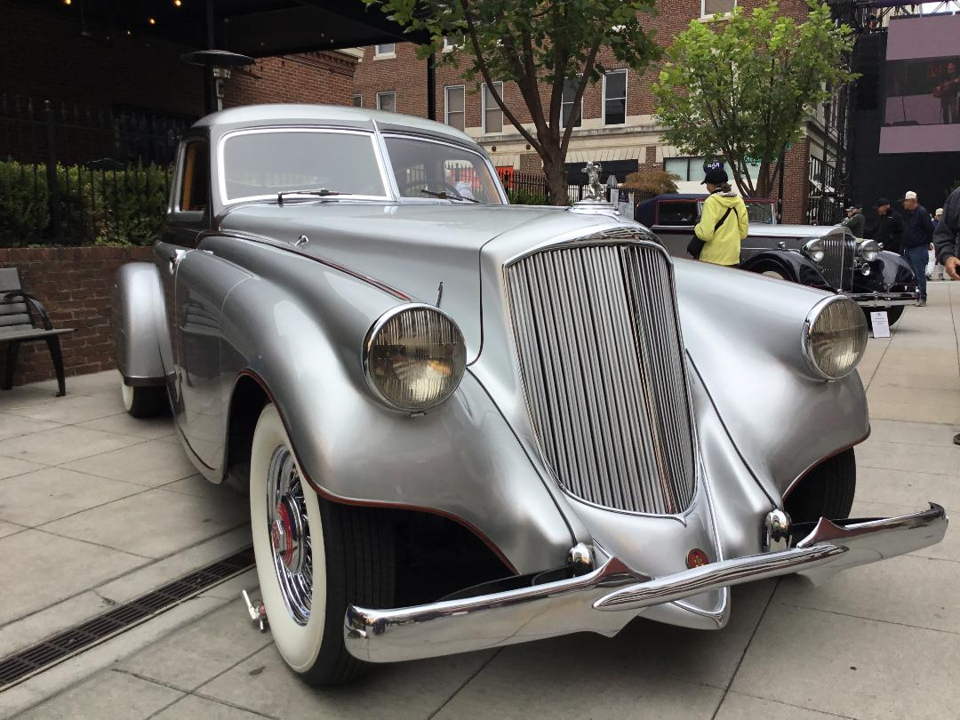

Mrs. d Imperial Towncar at Walter P. Chrysler”s Dedham bodi

VA SHOW-PHOTOS BY PRESIDENT MARTY LANE
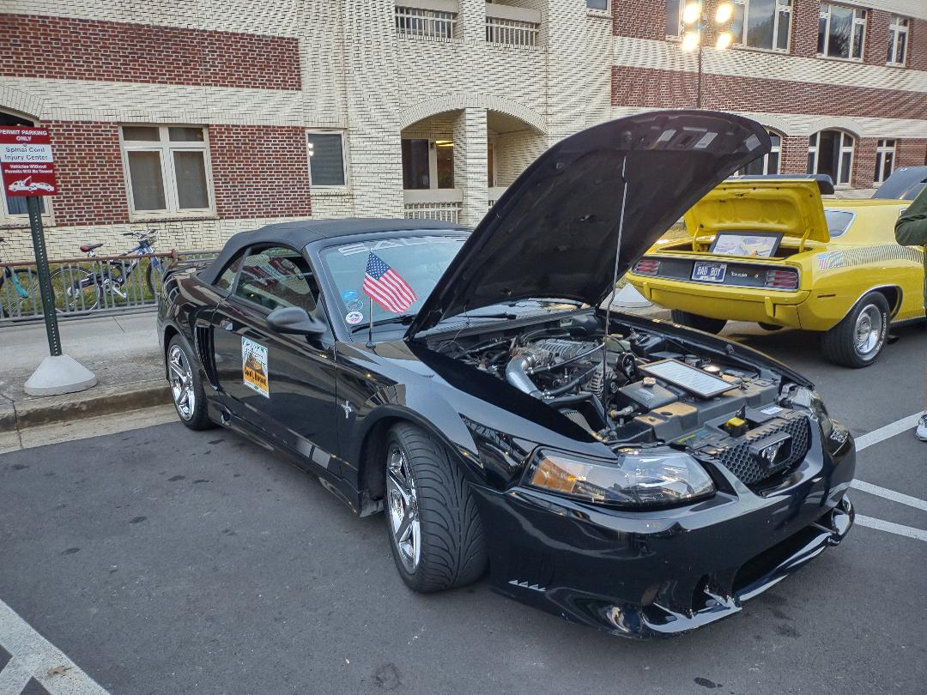
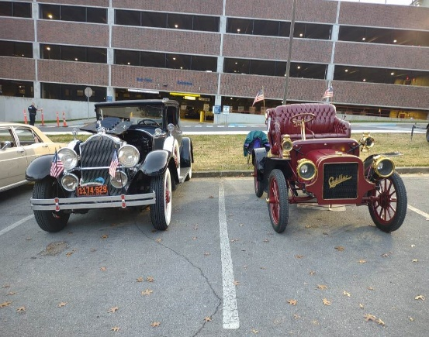
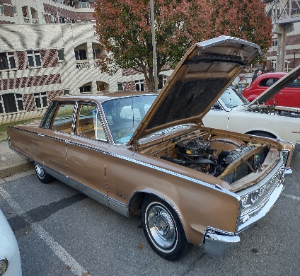
Thanks to Howard Irwin for all he did to make this show possible
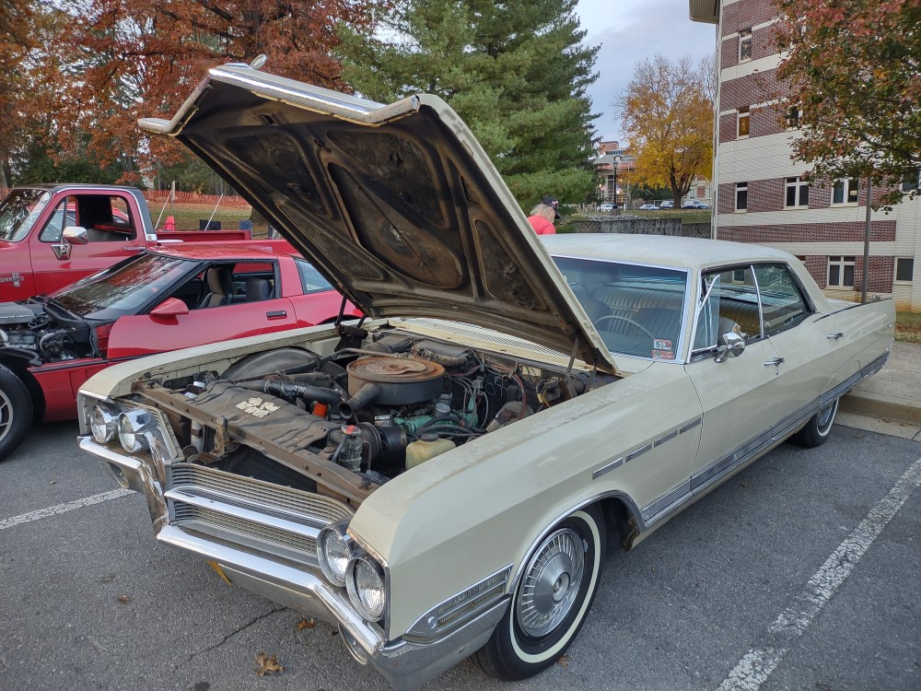
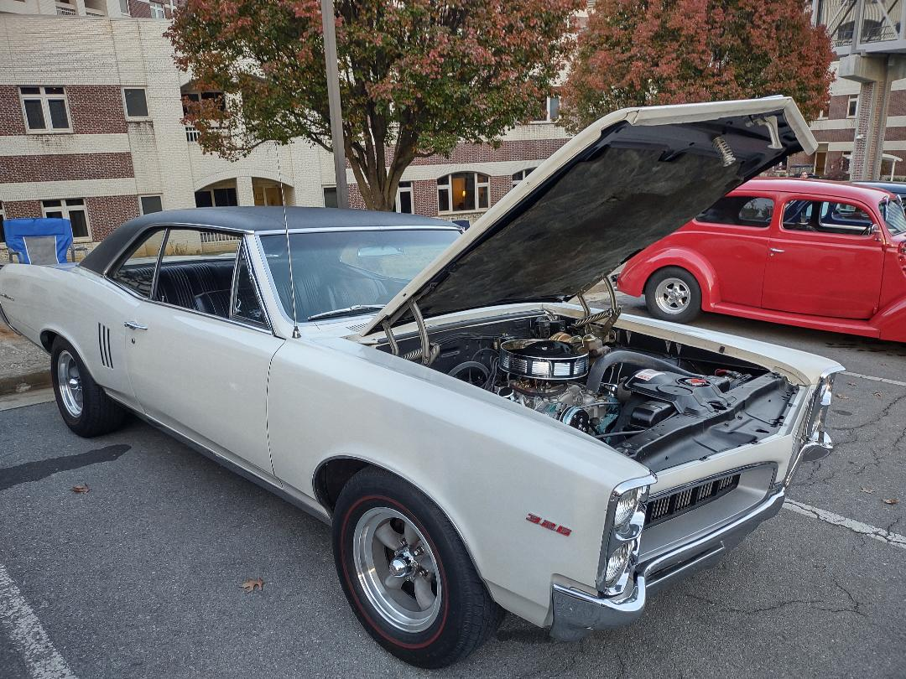
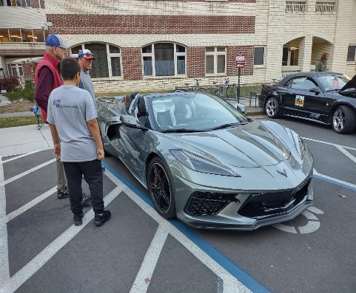
HAPPY THANKSGIVING
Sunshine and Shadows
Sergio Merluzzi will be returning to the hospital for a biopsy on an area of his neck.
Gene Archer has received treatments for Lymphoma.
Dave Williams is recovering from eye surgery.
Wayne Lambert no longer tests Positive for COVID.
JUDY WILLIAMS SPREAD SUNSHINE IN LEE COUNTY WHEN SHE CHAUFFERED DR. ART VAN ZEE AS GRAND MARSHALL OF THE 2023 TOBACCO FESTIVAL PARADE.

