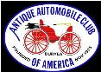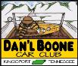
DAN’L BOONE REGION CAR CLUB
President Marty Lane 423-557-4159
Vice President Howard Irwin 423-530-6027
Secretary Sharon Williams 210-544-8583
Treasurer Wayne Lambert 423-276-3741 Sunshine David Williams 423-765-1095 Newsletter Editor Frankie S. Lambert 423-534-3358
Allandale Chairman David Williams 423-765-1095 Board of Directors Randy Still (Chairman), 423-245-4000 Sergio Merluzzi, Howard Osborne, Tom Wright
XLV August 2023
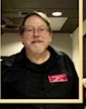

From the Desk of President Marty Lane August 2023

Greetings Car Aficiandos,
This summer is fast passing us by. Rain, heat waves, and plenty of car activities have kept us all busy.
FunFest is now over in Kinsport and our Annual FunFest Car Show was a resounding success. Plenty of nice weather, no rain and a large number of vintage and current automobiles were seen. There was even a pull behind camper with awning that created a makeshift campsite. Several members vehicles were on hand.
Heading up the Corvette representation was Gary Head's C8 Corvette present to represent the promotion of the Allandale Car Show coming up in Septemer.

Our Sonic Cruise-In on Friday July 27th was well represented with about 16 members in attendance with several member vehicles on hand. Other than the 95 degree weather, we all had a cool time with lots of good car talk.
Allandale show prep is coming along nicely with show t-shirts on the way. Several sponsors have sent donations in. We would like to continue to ask for support and get monetary sponsorships to help offset the cost of the show trophies,etc for Allandale. This year will be bigger than ever with the Corvette being the featured marquee.

Doe River Gorge trip that is coming up soon will need a head count as soon as possible. Please let Howard Irwin know if you are planning to attend.
This trip will take place August 26th, leaving Lowes across from Guiseppes at 9am sharp to caravan up to the Hampton area.

The next club meeting will be out Annual Club Picnic at Eastman Cabins, 406 Bays Mountain Park Rd Kingsport August 15th (Third Tuesday) at 6:00pm in CABIN #9 (The Large cabin on the right as you enter the park)
Sam Quillen will be our Club Chef serving up some tasty burgers and dogs from the grill.Plenty of food for all. We ask that you bring a side dish or dessert.
(Example, chips, cole slaw, green beans, beans, etc and cake, cookies, cupcakes or any favorite homemade dessert)
As always, I look forward to your participation and seeing you at our club events.
Happy Motoring!
Marty Lane
President Daniel Boone Chapter AACA `

.

Gary Head William Bill Anderson
Randy Still went to the FunFest Car Show and look what he saw. We should have been there.
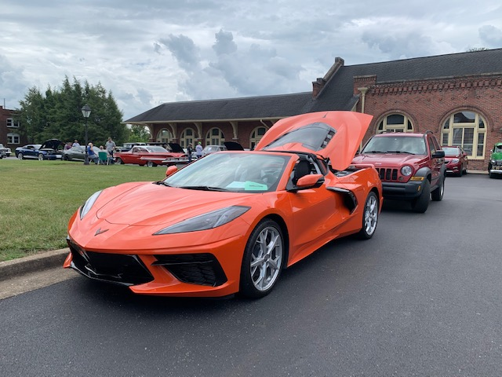
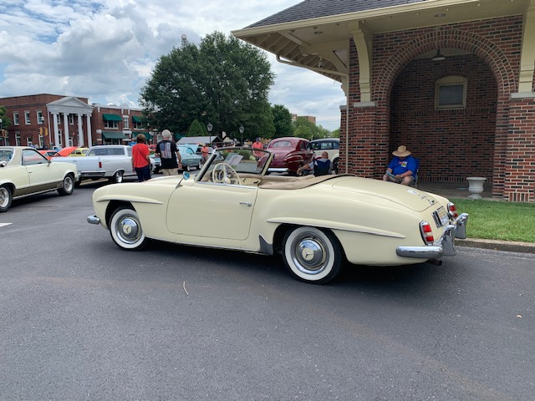
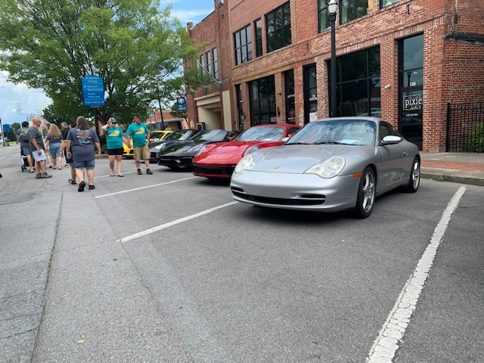

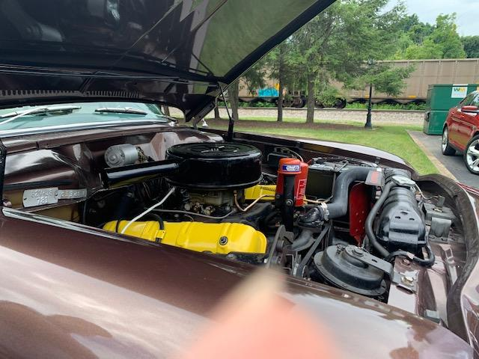

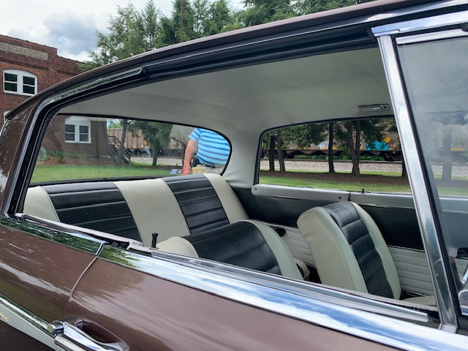
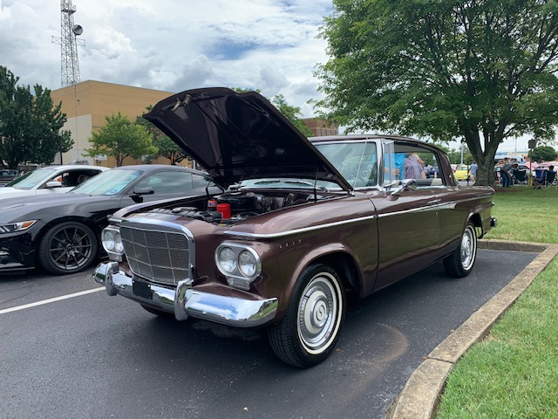

Matt Caldwell’s Studebaker Daytona Interior of Studebaker Interior view of Studebaker’s Engine
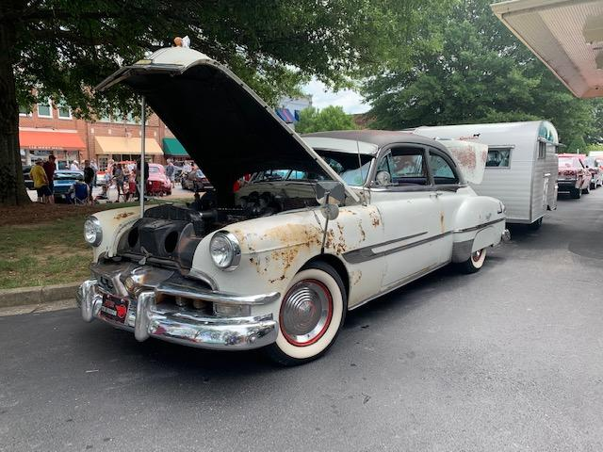
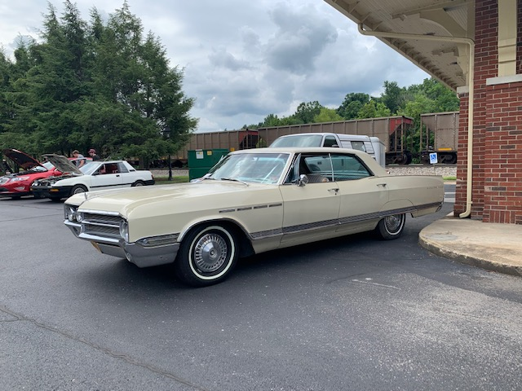
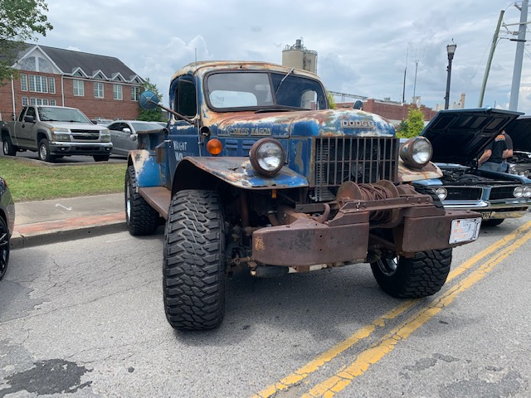

Marty and Debbie Lane’s Buick

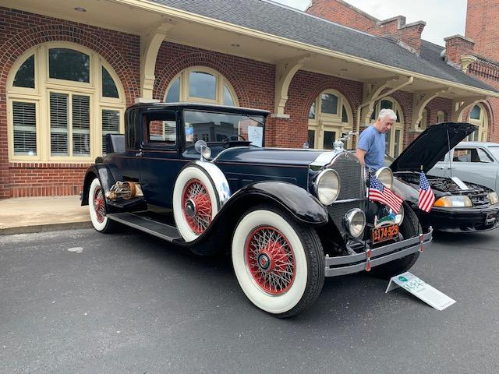

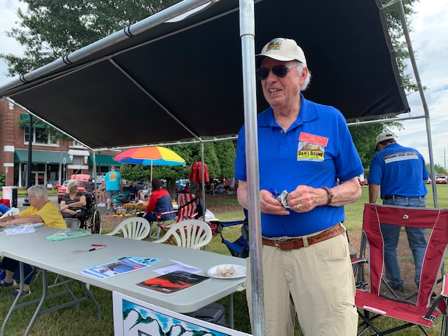
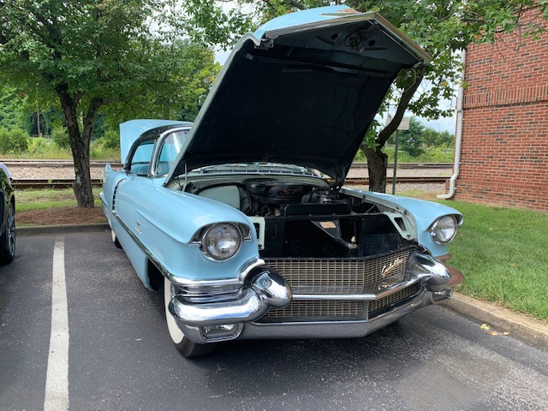

Howard Irwin’s 1928 Packard

Anything can happen at a FunFest Car Show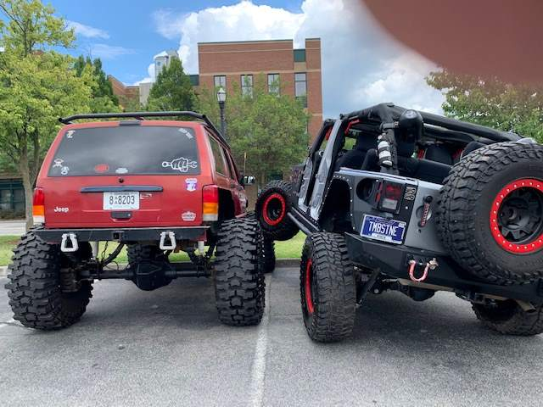

If you don’t already know, Giuseppe’s will close at the end of the year, I called the restaurant and confirmed the news when I first heard that it had been sold. FSL

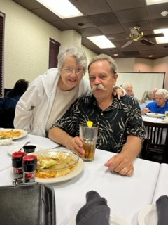
Say Hi to new members

DAN’L BOONE CAR CLUB MINUTES: JULY 18, 2023, Meeting called to order by President, Marty Lane at 7:15 pm, Pledge Allegiance, and Prayer by Bill Anderson. 26 members plus guests.

Treasurers’ and Secretary’s Reports were given and approved by membership. Sunshine/Shadows: Becky Williams recovering from a fall and in attendance.
OLD BUSINESS: Howard Irwin gave an update on a cruise into the Doe River Gorge Scenic Train Ride in Hampton, TN scheduled for Saturday, August 26, 2023. Members wishing to caravan, meet at Lowes (Stone Drive) at 9:00am. Train Tickets and bag lunch can be purchased from the location upon arrival. All proceeds will support Christian Day Camp.
Dave Williams encouraged everyone to attend our FunFest Car Show this Saturday, July 22, 2023, 10am-2pm. Location: Downtown Kingsport at the Citizens Bank parking lot/train station area (intersection of Main and Broad Streets). Members were asked to assist with morning prep and work at the registration table. Special thanks to Lillian for bringing lunch items and those members that worked at registration.
Randy Still called a board meeting on July 12, 2023. Board members prepared letters to be mailed for sponsorship of the Allandale Show. Randy made a commitment of $1,000 on behalf of Still Transfer. Other donations: Bill Anderson-$200, Champion Chevy $200, Farmer Bureau Insurance, $50, Rainbow Motors, $200 (Lillian Constant), and Judy Williams (Axe Handle Distillery,$200.
NEW BUSINESS: Sam Hauck has planned for our annual club picnic to be held Tuesday, August 15, 2023, at Eastman Rec. Area (Bays Mountain), Shelter #9. 6pm. Members were asked to bring sides and dessert. Everything else is provided. If you would like to assist the grill master, Sam, show up around 5:15pm. Also, this will be our regular monthly meeting. Norma Safriet thanked those who participated in the annual Nottingham United Methodist Church car show held July 8. 52 cars were present, and all funds will go to the church Randy Still gave a slide presentation of the Keeneland Concours d Elegance held in Lexington Kentucky. Randy and Gary Head attended the event and Gary’s 91 Chevy Corvette was shown.
Reminders: Our Sonic Drive In Cruise In, July 28, 2023, at the Colonial Heights location (intersection of Moreland and Ft. Henry Drive. August 12th Woody Puritan Club Presents Axe Handle Distillery’s 3rd annual car and bike show (1-4PM). See details on Axe Handle Distillery FB page.
Respectfully submitted,
Sharon Williams, secretary
2023 Calendar

Every Saturday Evening from now till end of October - Elizabethton Downtown Cruise-In

Aug 5th 4-8pm - Bloomingdale Puritan Community Fest - Ketron Elementary 3301 Bloomingdale Road Kingsport -Reg $20

Aug 5th 10am-4pm Pharoahs 2961 N John B Dennis Hw Kingsport - reg $20

August 12, 2023 -Axe Handle Distillery Car/Bike Show

August 15, 2023-Car Club Picnic -Bring sides or desserts, other items will be furnished.

August 26, 2023- Doe River Gorge Cruise -In and Scenic Train Ride for Dan’l Boone Region Members. Meet at Lowes on Stone Drive. 9 AM.

-September 17, 2023, Allandale Show

The Sonic Cruise-In takes place on the Last Friday of the Month, 6pm at the Sonic Drive In in Colonial Heights, Kingpsort and will continue until the fall. Per our deal with Sonic, club members get a 50% discount on all menu purchases during the Cruise-In.

