Fourth Annual Classic Cars for Classic Seniors Cruise In
Saturday, June 17th
The Laurels Retirement and Assisted Living Center
10:30 AM - 12:30 PM
5635 BSG Road Norton, Virginia

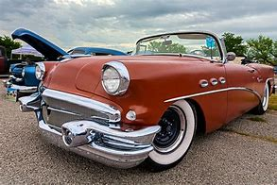

Its Back!!!!
1950’s theme and dress! Be there or be square!
All classic, muscle cars, trucks, and special interest vehicles invited!
Various trophies will be awarded including:
Laurels Residents, Laurels Staff, Dan’l Boone Car Club, Lonesome Pine School and Heritage Center, Garnett Gilliam Historical Preservation and Best in Show!
Dash plaques to first 40 registered! All registration done on Site!
Refreshments will be served. Recommended donation of $10 to cover show expenses
Sponsors: Lonesome Pine School and Heritage Center, Dan’l BooneCar Club,The Laurels
The Meet in Loving Memory of Garnett Gilliam- Laurels Resident - Educator -Historian Friend
We hope to see you at the 45thAnnual Allandale Car Show on Sunday September 17th
Dave Williams: 571-499-3588 or swvakid@charter.net danlbooneregion.aaca.com

