45th Annual Allandale Car Show
Sunday, September 17, 2023
Registration 9 AM - 1 PM Awards: 3 PM

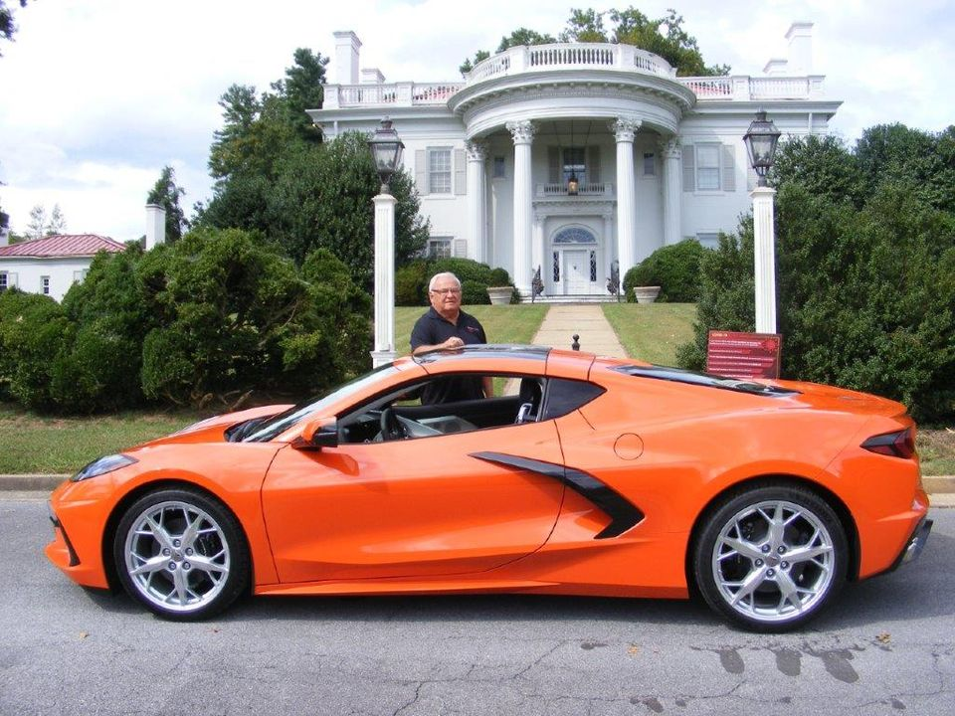

Special Lawn Display: The Eight Generations of Corvette
Registration $15 – Day of show only - No early registration
Requested Spectator Donation $3 each Square accepted
(Children under 12 free)
Top 25 & Special Award Plaques. Dash Plaques to the first 300
Cash Prizes Placed in Random Registration Packets
Free Hot Wheels Toys for the Kids
Limited Edition T-Shirts Available - Design by Graphix Plus
Mansion Display -The Gary Head Corvette Memorabilia Collection
2023 Show Artwork Vehicle Display
1907 Cadillac Model M
1963 Mercedes Benz Convertible
2023 Corvette C8
The Allandale Show always welcomes vehicles of ALL types and descriptions - brass through contemporary. classics, muscle cars, rat rods, low riders, imports, tractors, motorcycles
The Dan’l Boone Car Club especially invites owners and aficionados of the eight generations of Corvettes spanning 1953 to 2023
All Chevrolet Corvette dealers and Corvette clubs invited
Special show logistics by the West Ridge High School JROTC
Delicious breakfast and lunch items served throughout the show by the:
West Ridge High School Band Boosters
For Show Sponsorship: Dave Williams 423-765-1095 or swvakid@charter.net
The Allandale Mansion is located at 4444 West Stone Drive Kingsport TN
http://danlbooneregion.aaca.com/
See us on Facebook at: Dan’l Boone Car Club
Note: Neither the Antique Automobile Club of America (AACA), the Dan’l Boone Region nor any of its personnel is in any way responsible for any liabilities, fire, theft, or vandalism. Each vehicle owner is responsible for his/her vehicle on display. Alcoholic beverages and bicycles not allowed on premises. All pets must be on leash with clean up done by owner. Canopies erected in show entrance/egress routes must be moved. Dan’l Boone members are never eligible for any awards or prizes. No award plaques will be mailed to recipients. Show will be held rain or shine September 17. No rain date.

