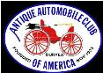

DAN’L BOONE REGION CAR CLUB
President Marty Lane 423-557-4159
Vice President Howard Irwin 423-530-6027
Secretary Sharon Williams 210-544-8583
Treasurer Wayne Lambert 423-276-3741 Sunshine David Williams 423-765-1095 Newsletter Editor Frankie S. Lambert 423-534-3358
Allandale Chairman David Williams 423-765-1095 Board of Directors Randy Still (Chairman), 423-245-4000 Members at Large: Sergio Merluzzi, Howard Osborne, Tom Wright

XLV April 2023
- From the Desk of President Marty Lane April 2023

Greetings,
As we go into the Easter Holiday season, let us remember to give thanks for all of our blessings and be sure to spend time with family and friends as they are certainly our greatest assets in life. And be sure to drive those classic cars for all to see and to get them warmed up and out of mothballs for the Spring season.

Our automotive year is full of many varied events that we can look forward to including but not limited to our Fun Fest Car Show downtown and the much-anticipated Allandale Event with the Corvette Anniversary being our special theme.
Gary Head has been coordinating the collection of memorabilia to be featured in the Allandale mansion during our Corvette 70th anniversary celebration.

Randy Still recently visited the Cofer Collection in Atlanta. He has a video presentation of the superb car collection that he had the pleasure of seeing in person. The collection features several vintage treasures plus a Duesenberg to put the cherry on top.

The next upcoming event for AACA is the Charlotte Auto Fair on April 13-16th at Charlotte Motor Speedway. The Davey Crockett AACA club has Friday night cruise-ins at Town Square Shopping Center in Greeneville TN starting April 14th from 5-8pm.

Our April meeting and dinner is going to be on our usual Third Tuesday of the Month, TUESDAY April 18th.

I’m sure 2023 will be a wonderful year for the club and I look forward to our upcoming auto adventures, (and the Allandale Corvette Celebration).

Marty Lane
President
AACA Daniel Boone Region

\\\\\\\\\\\\\\\\\\\\\\\\\\\\\\\\\\\\\\\\\\\\\\\\\\\\\\\\\\\\\\\\\\\\\\\\\\\\\\\\\\\\\\\\\\\\\\\\\\\\\\\\\\\\\\\
2022
Last Axe Handle Car and Bike Show- photos by Frankie L.
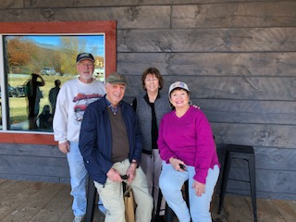
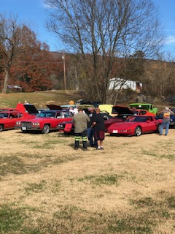
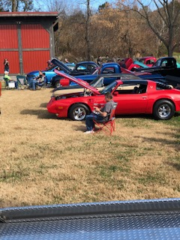
Food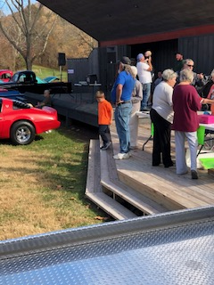
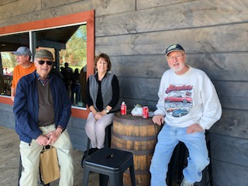
Woodway Ruritan Club Presents

AXE HANDLE DISTILLING’S ANNUAL CAR AND BIKE SHOW!

May 20th 11am-2pm at Axe Handle
42236 Wilderness Rd
Pennington Gap, VA 24277
276-318-6162

Free admission and Entry

• Food truck onsite!
• Door Prizes!
• Distillery will be open 10am-8pm!
• Live Music!
• Free Tastings!
• Just 45 minutes from Kingsport, TN!

Love your car!
Love your car
If you are a Board Member of the Club, please attend the Board Meeting on Thursday, April 13th at 6:30 at Randy Still’s file storage building on Cumberland Street.
Sharon Williams will be reading the March Minutes at the next meeting. Sharon, as always sent them to me but my computer would not co-operate.
The April 18th Meeting of the Dan’l Boone Region Antique Car Club
at Giuseppe’s will start at 6:00 PM. to mix, chat and order your food. The meeting starts around 7:15. Members can RSVP if they plan to attend via email To marty_in_easttn@yahoo.com, please do so by April 14th.

The Treasurer thanks everyone for paying your local dues!!!!!!!!!!!!!!

