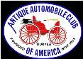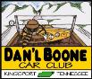

DAN’L BOONE REGION CAR CLUB
President Randy Still 423-245-4000
Vice President Marty Lane 423-557-4159
Secretary Sharon Williams 615-525-6216
Treasurer Wayne Lambert 423-276-3741 Sunshine Newsletter Editor Frankie S. Lambert 423-534-3358
Allandale Chairman David Williams 423-765-1095 Board of Directors Don Wood (Chairman), Members at Large: Sergio Merluzzi, Howard Osborne, Tom Wright

XLIV December 2022
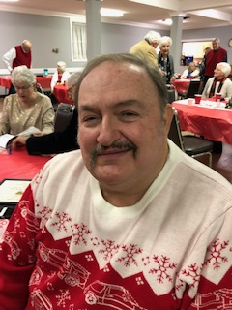
RAMBLINGS FROM RANDY –December 2022

Where did 2022 go? I can hardly believe that it is time for our Christmas Party. Though, I have had multiple surgeries this year, I am pleased to say that I have not missed a Region Meeting. The care, support, and prayers of our members have helped see me through a difficult time.

On Tuesday, December 13th, we will gather at Giuseppe's for our annual Christmas Dinner. We will each pay for our own dinner as usual, but you NEED TO RSVP to me by noon on DEC. 9. e-mail rstillcars@aol.com or call or text to 4233.335.0675. We will review the year and install our new officers for 2023.

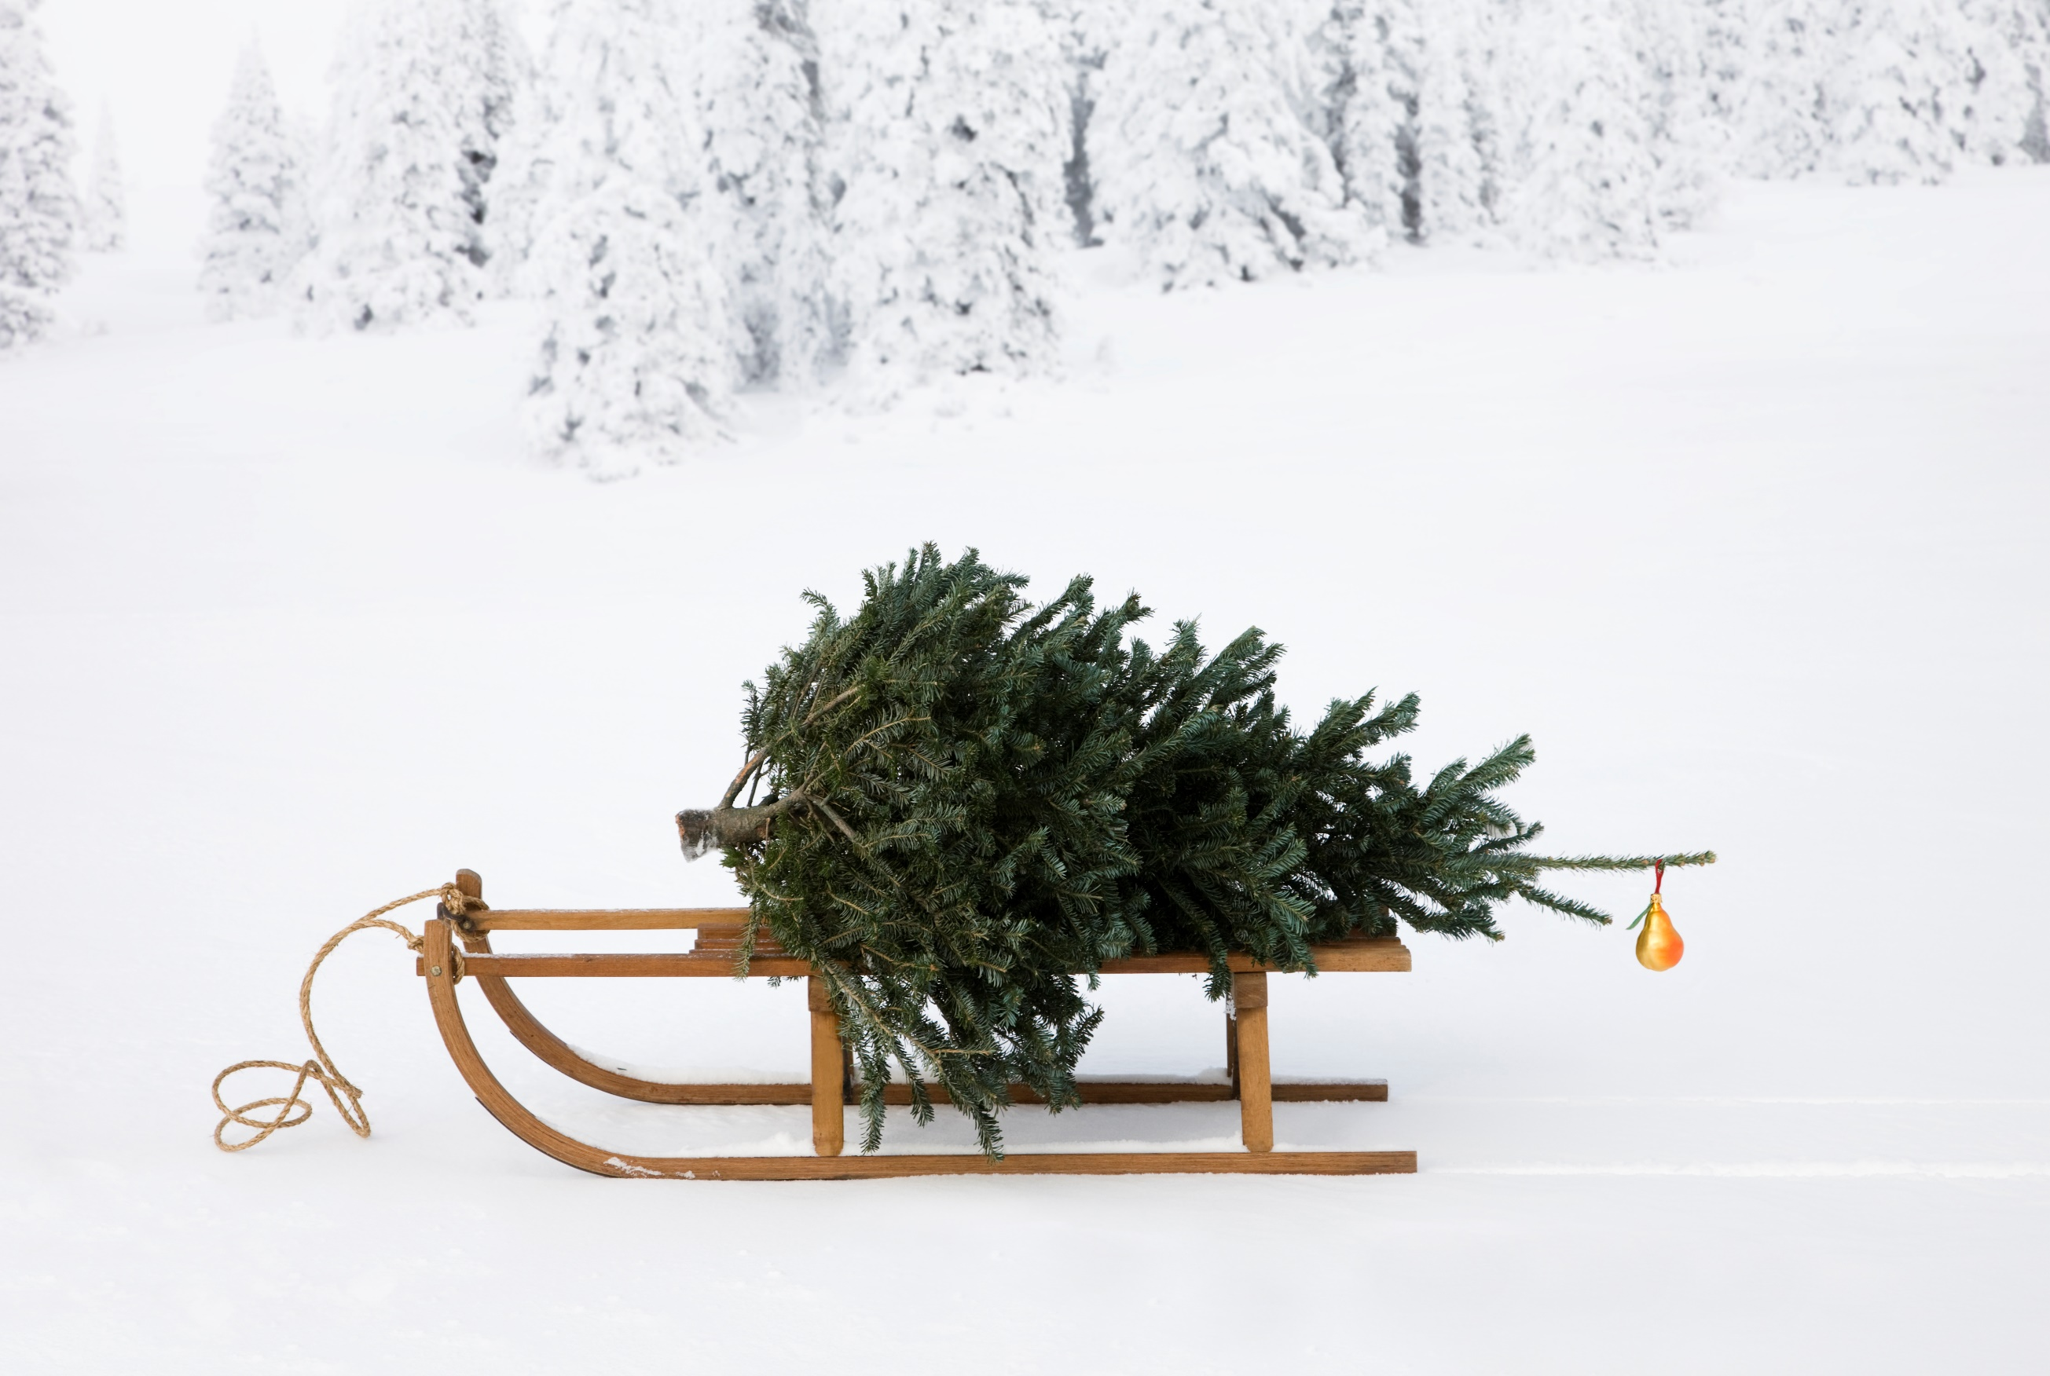
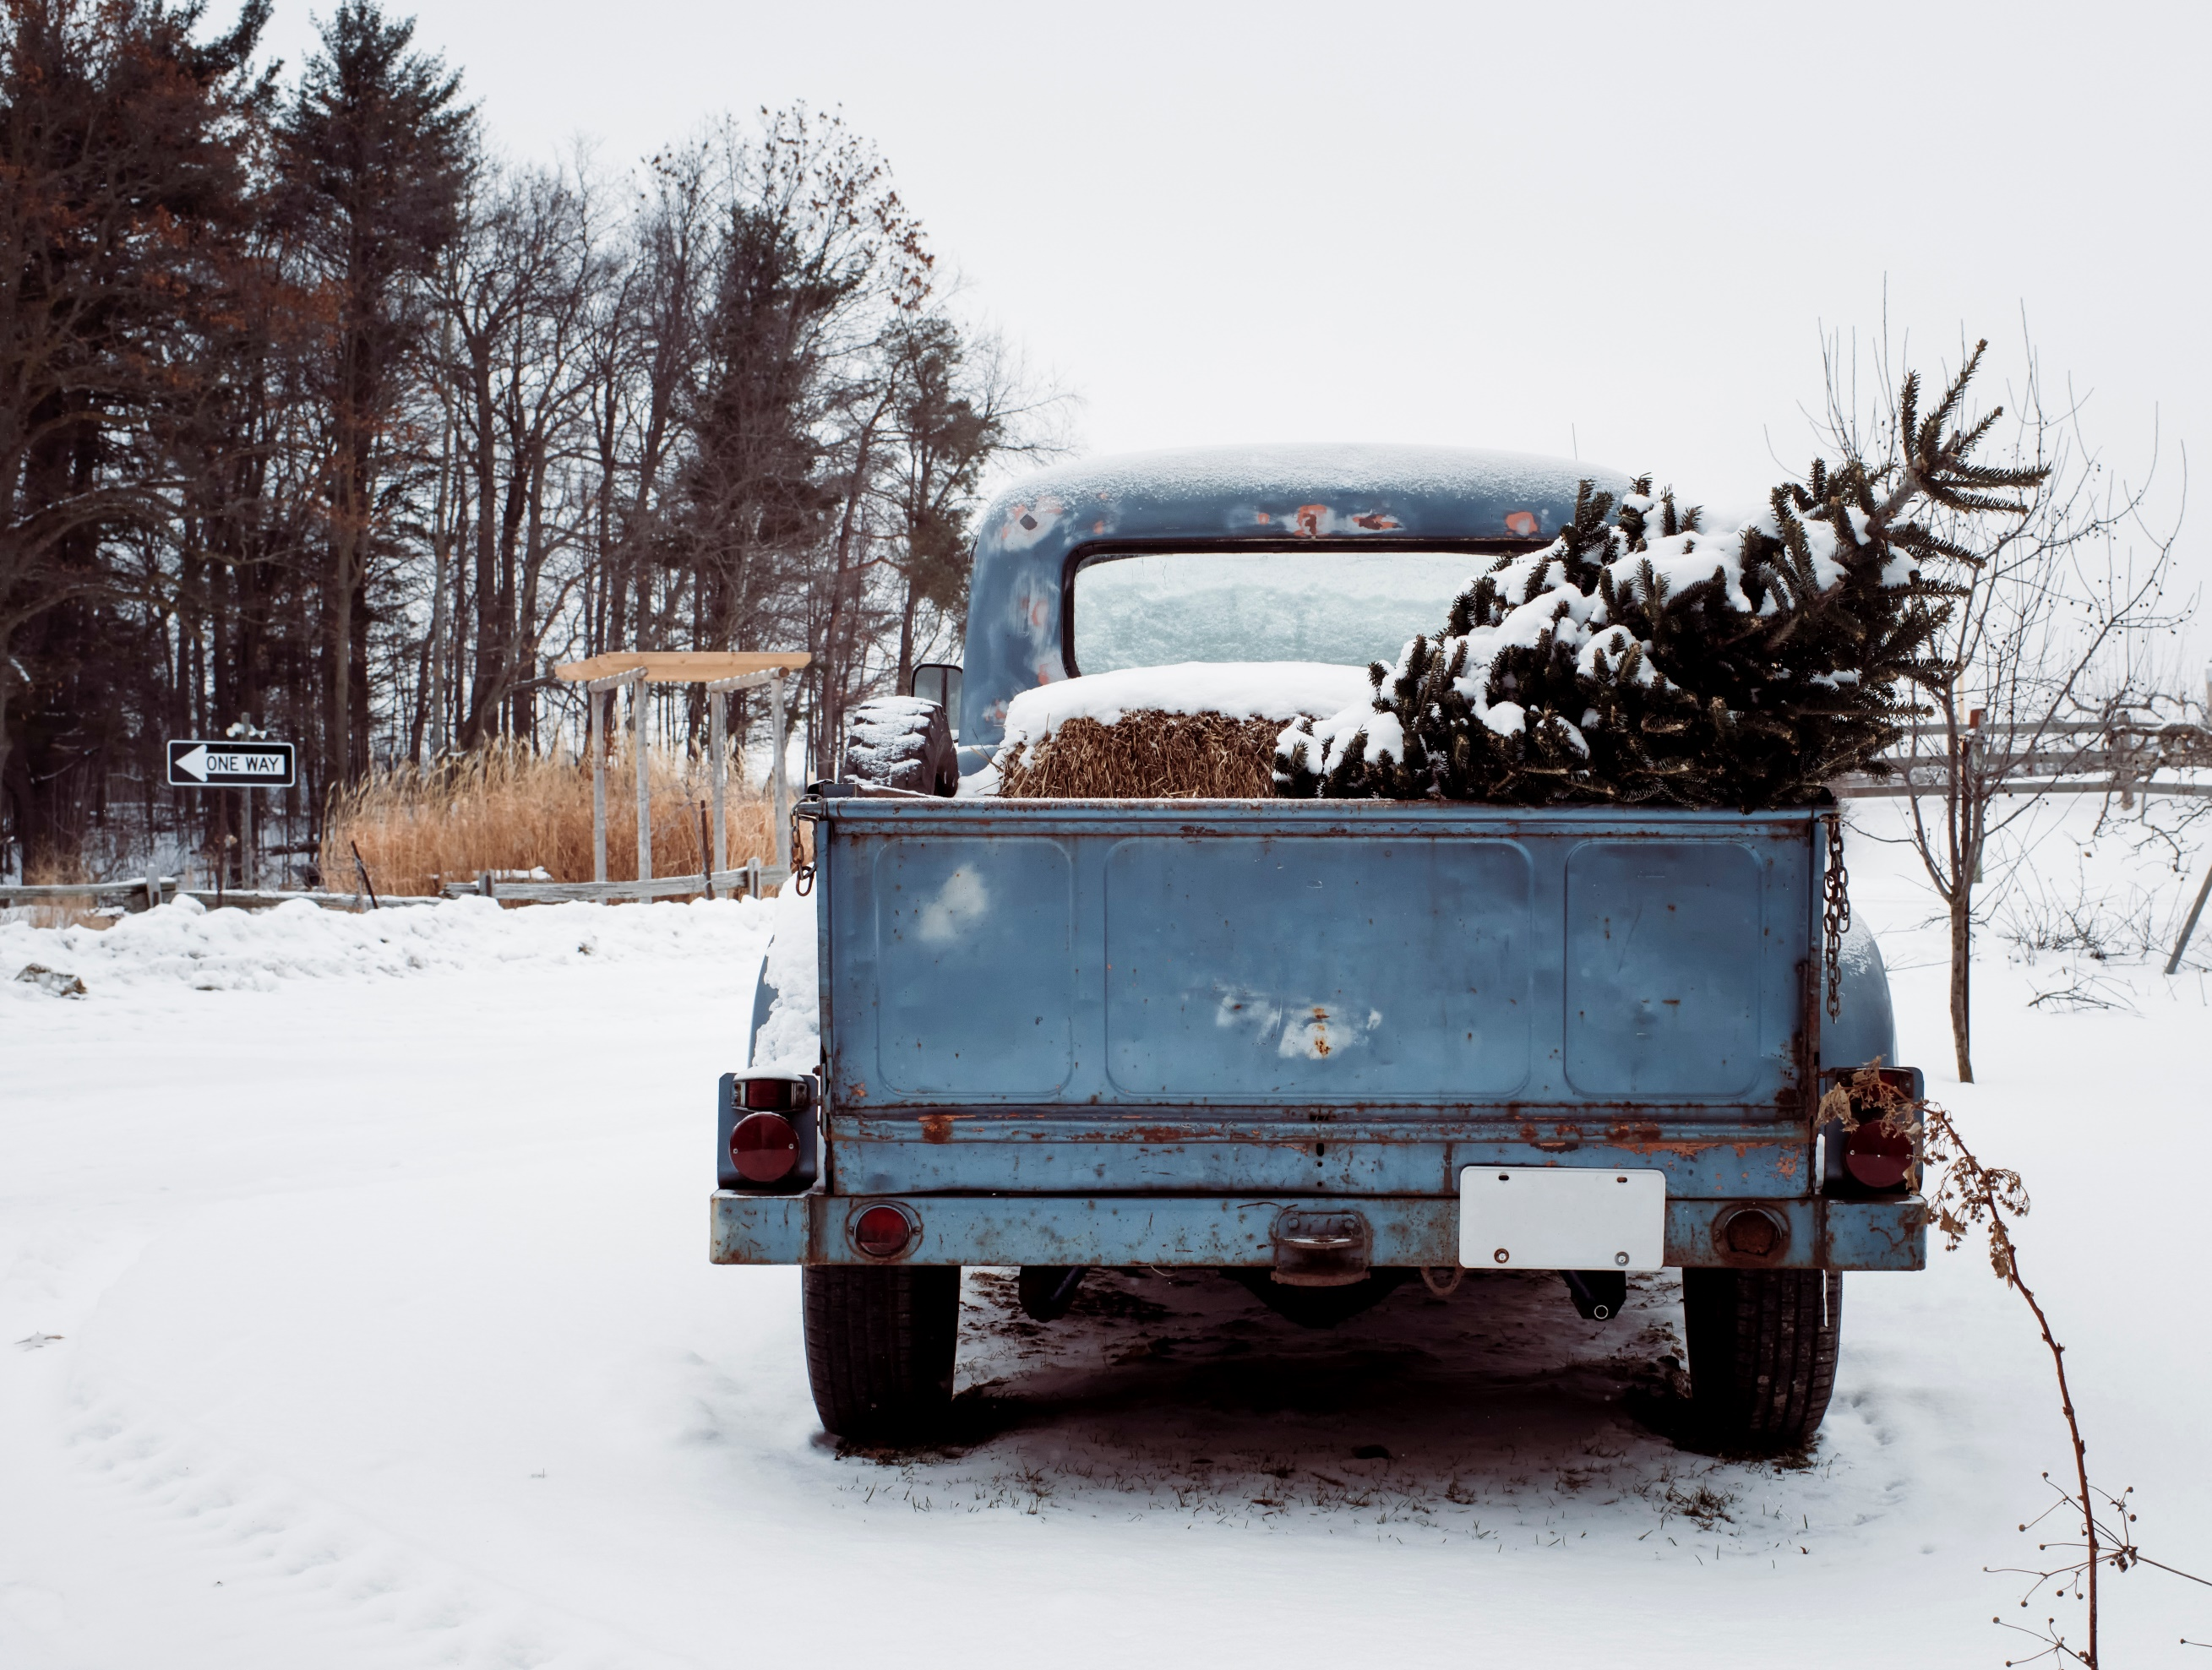
Randy

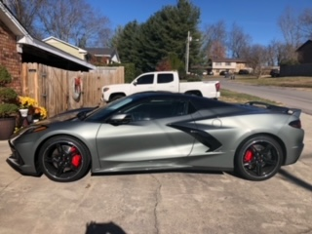
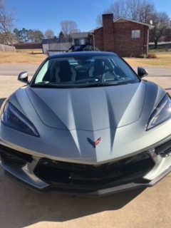

Gary Head’s new 2023 70th Anniversary Corvette Convertible
It appears that Santa came early to the home of Gary Head !

We send Sympathy to Pam and Howard Osborne on the passing of Pam’s Mother.
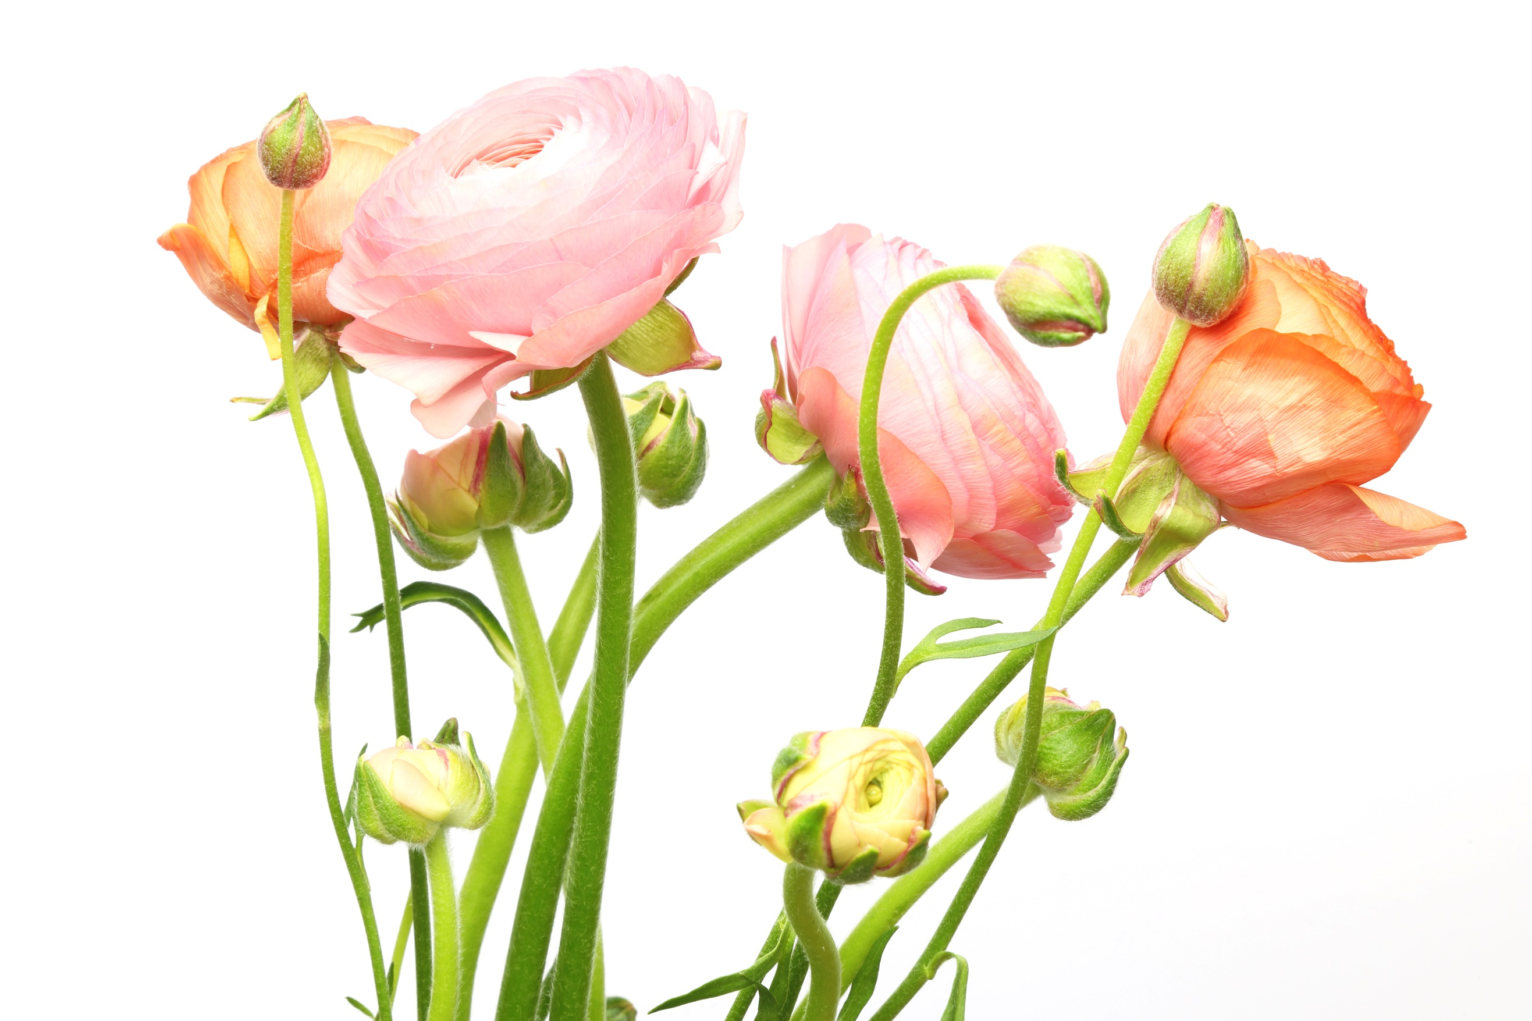

Calendar of Events

Dec. 3 Annual Region Christmas Banquet, Giuseppe's 6PM
Jan. 23, AACA National Meet, Miami, FL
Feb. 9-11 AACA National Convention, Williamsburg, VA
Feb.25 Boca Raton Concours, Boca Raton, FL
Mar. 4-5 The Amelia, Amelia Island, FL
Apr. 15 AACA National Meet, Charlotte, NC
Apr.30-May 3 Southeastern AACA Divisional Tour. Oak Ridge, TN
May 7 Greenbrier Concours, White Sulphur Springs, WV
May 18-20 AACA National Meet, Gettysburg, PA
June 11 Ault Park Concours, Cincinnati, OH
July 15 Keeneland Concours, Lexington, KY
July 26-29 AACA National Meet, Norwich, NY
May 27 Wilderness Trail Rod Run, Downtown Kingsport
Aug. 10-12 AACA Grand National Meet, Bettendorf, IA
Aug. 20 Pebble Beach Concours, Carmel, CA
Sept. 17 ANNUAL REGION MEET at Allandale Mansion, Kingsport, TN
Oct. 3-6 AACA National Meet, Hershey, PA
Nov. 3-5 Hilton Head Concours, Hilton Head Island, SC

It is time for Membership Renewal, the form is found in your last edition of Antique Automobile Club of America, Inc.

It is also time to pay your Dan’l Boone Membership Dues. $15 for individual and $20 for family.

Merry Christmas
This is a photograph from Grove Park Inn’s Gingerbread Show in 2020
Courtesy of Randy Still.
