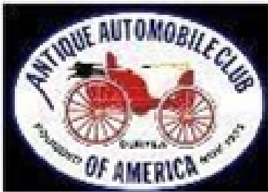
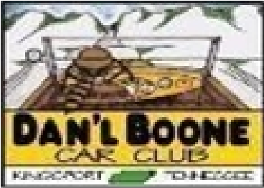

DAN’L BOONE REGION AACA NEWSLETTER
President Howard Irwin 423- 530-6027 Vice President Don Wood 423-929-3299
Secretary Randy Still 423-245-4000
Treasurer William Anderson 386-795-2254
Sunshine David Williams 423-765-1095
Newsletter Editor Frankie S. Lambert 423-534-3358
Allandale Chair David Williams 423-765-1095
Board of Directors Marty Lane (Chairman ) 423- 577-4159
Fred Counts, Sergio Merluzzi, Howard Osborne, Tom Wright
Dan’l Boone Region AACA
President Howard Irwin

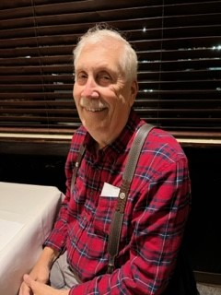

Happy Labor Day to all! Where did the summer go? A great August is now in the books and we’re headed into September with our crowning event of the year, a couple of weeks away. Before we get into those details, let’s recap August. In addition to some local shows our club caravaned to our neighbor regions. Dan’l Boone Car Club members went to Bristol Hot August Nights. We had 5 cars from the club participating, with questionable weather forecast, which turned out to be true. What a rain storm! Regardless of the weather, we had fun and enjoyed seeing many cars in the great State Street setting. We had some great food and listened to some fine bluegrass music while the rain soaked the street. It cleared up in time for awards and travel home about dark. Looking forward to doing that again next summer.
The following Friday night was our August Sonic Cruise-in which was well attended. Some photos are included. Next on the August calendar was our Doe River Gorge outing Saturday, the 24th, which took the place of our August meeting. The weather turned out to be beautiful and we ended up with 35 folks in attendance, which included 7 guests, several of whom have expressed interest in joining our club. Although some of us drove our modern rides, we still ended up with 20 cars making the trip. The feedback I’ve heard was all good and we’re looking forward to making this trip again in the future. Also, photos of this outing are included. Those of you who attended probably noticed the construction of the “Christmas Train Project” underway at the Doe River Gorge Camp.

I’m including a link for more information including some artist renderings of their plans for the Christmas Train. It’s a big project, estimated at $5.85 Million. Enjoy taking a look at this website: Christmas Train | Doe River Gorge
Now for September. Dave Williams has been extremely busy pulling together all the details for our September 15th Allandale Show. We’re expecting about 150 Mustangs from the region in addition to our regular attendees. With clear weather we could top 400 cars on the show field. Before all that can happen, we have a few activities planned to finish the detailed work. On Tuesday, September 3rd our Board is meeting and welcome others who want to help with a work meeting to assemble packets for the expected 400 entrants. Details of this meeting are in the schedule included with this newsletter. We will follow up the September 3rd meeting with our regular monthly meeting at Zachary’s Steakhouse at 6pm on Tuesday, September 10th. Please plan to attend. We’ll enjoy dinner together and work out the details of who can help when for our Sunday, September 15th Allandale Show. We will need volunteers for several activities during the day, beginning with setting up the tents, signs and barricades beginning at 7am or so that morning. Again, please plan to attend and sign up to help with the Allandale Show.
Club activities for September will wrap up with our last Sonic Cruise of the year on the Friday following the Allandale Show. Let’s all plan to come and enjoy the fellowship and the 50% discount at the Sonic in Colonial Heights on Friday, September 20th. Wrapping up the month, there are some local area shows on September 28th and 29th which are noted in the calendar.
Looking ahead to October, we plan to caravan to the Cranberry Festival at Shady Valley, TN on Saturday, email. The parade and festival are a nice fall addition to our club activities and I hope you can make this event. Our October meeting will be on the following Tuesday, October 15th, again at 6pm at Zachary’s Steakhouse.
Thanks again for your help and participation in our club!
Howard
If you haven’t paid your 2024 dues or you are not sure, please check with William Anderson at the next meeting or send to.
William Anderson, Treasurer
3204 Highway91
Shady Valley, TN 37688
Remember single $15 To become a new Member
Couple $20 send your information and dues to the Treasurer

More About the Legendary Allandale Car Show
The calendar says its September so it must be time for our annual fall AACA meet better known as “The Legendary Allandale Car Show.” In this case it is our 46th. As you are aware we select a specialty every year to attract interest in attendance and hopefully gain new members. Over the years we have highlighted various marques to include orphans and even Rad Wood (80’s and 90’s vehicles.) This year we will recognize The seven generations of Mustangs, America’s pony car, manufactured between 1964-2025. All Mustangs in attendance are invited to park on the mansion grounds in a special display. In the past ten years the highest Allandale attendance has been the 50th anniversary of the Ford Mustang. The total show attendance in 2014 approached four hundred. This year Ford Mustangs representing each of the seven generations will be parked along the walk in front of the mansion. Three area Mustang clubs are sponsoring the special display. Melissa McIntosh’s 31 Ford Model A, Pam Osborne’s 66 Mustang Sprint and Dr. Pete Renfro’s Cervini modified 2005 Mustang GT appear on our 2024 artwork as featured on shirts, dash and award plaques.
A Mustang memorabilia display will be featured on the grounds and in the mansion. The Appalachian Scale Modelers Association will provide “Make and Take” models as well as free Hot Wheels or Matchbox toys for the kids. Free 50th Mustang anniversary memorabilia will be available to all show participants.
We will again receive invaluable show support from nearby West Ridge High School. Spectator donation, parking, and other show logistics will be provided by the award-winning West Ridge High School Air Force JROTC. The cadets will present a color guard at 12:00PM. They gladly accept attendee donations. A portion of our show receipts annually support their fund-raising efforts. The West Ridge High School Band Boosters will provide hamburgers, hot dogs and other refreshments. Please patronize them, partake of their excellent breakfast, and lunch food selection to assist with their fund-raising efforts. The boosters are self-supporting and appreciate our invitation.
T-shirts designed by Kingsport artist Gary Bortz of Graphix Plus are available for $15(S-XL) and $20 (2XL and up) at the show registration tent. We ask that each club member purchase a T-shirt as it is a walking advertisement for our growing and activity-based car club recognized in the Tri-Cities. These shirts from various past years are often seen at area shows. . I recently saw a shirt from 2012.

As is our usual practice, top 25 vehicles receiving the most owner votes will receive award plaques. Additional awards include show chair, president, Bortz Graphix Plus, Varsity Trophies, Sonic Drive-In, JROTC, Appalachian Scale Modelers, club participation, long distance, oldest vehicle, best of show, hard luck, Woody Fleenor award, Dave Berry award, Still Family award and Wallace Ford best of show. Eight award plaques along with a framed Mustang postage stamp will also be presented to each of the seven generation Mustangs featured on the Mansion front walk display. Finally,

Mustang awards include best of show Mustang, Mustang Club participation and best theme Mustang.
The club appreciates the leadership of President Howard whose coordinated efforts have tasked club members to secure financial sponsors. These efforts result in show success. Finally, a big thank you to Sam Hauk and Neil Townes whose dedication in setting up the show for the past two decades has contributed to our successful meets. We are in search of a team to assume this responsibility in 2025, so step right up. Thank you one and all for what each of you do as we look forward to the 15th!
As requested by the editor-Dave Williams responded, Thank you Dave. Frankie Lambert

8/27/24
Photographs from the Sonic Cruise-In-Randy Still
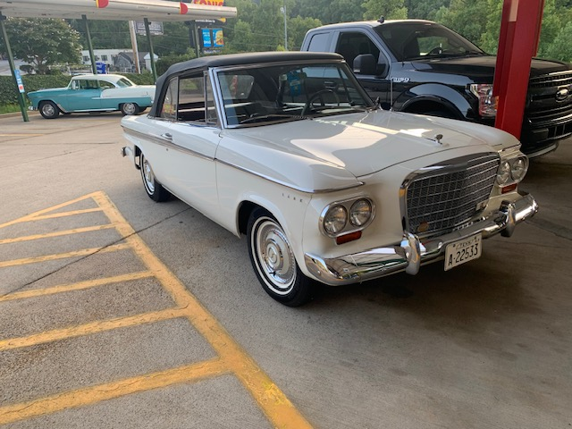
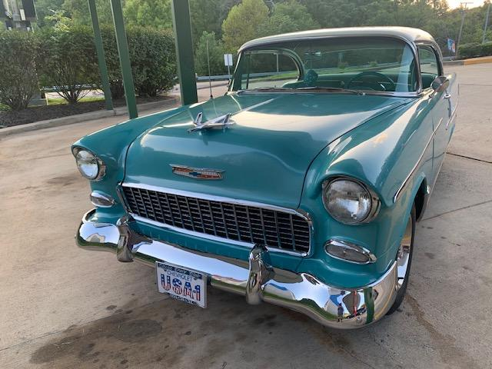

Bob Hathaway’s Studebaker Convertible

Sergio Merluzzi’s 2006 Mercedes
Randy Still’s 1982 Porsche 928

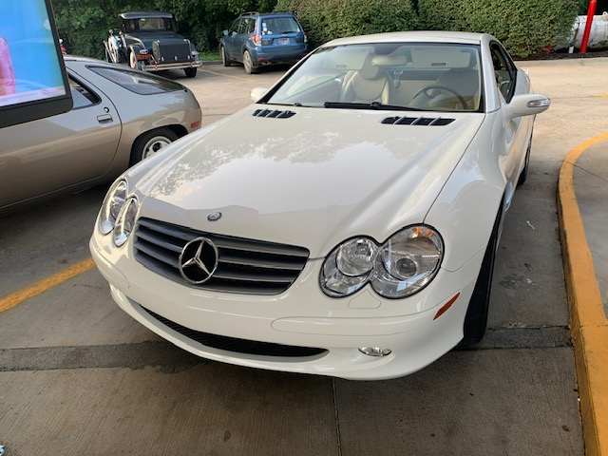
Tom and Betty Wright’s 1956 Chevy

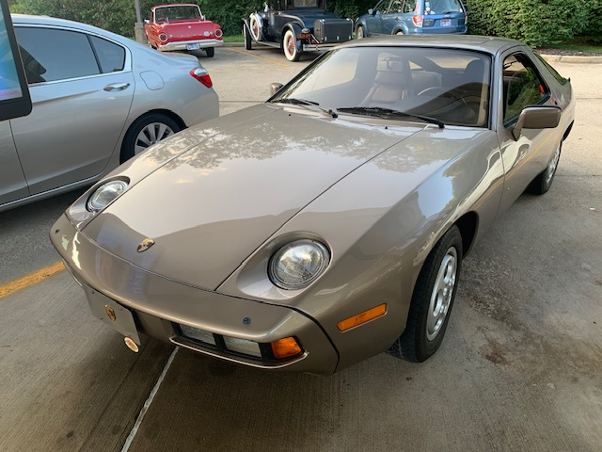

Sonic Cruise-in
Members enjoying Social and Car Talk
Photos by Howard Irwin & Randy Still

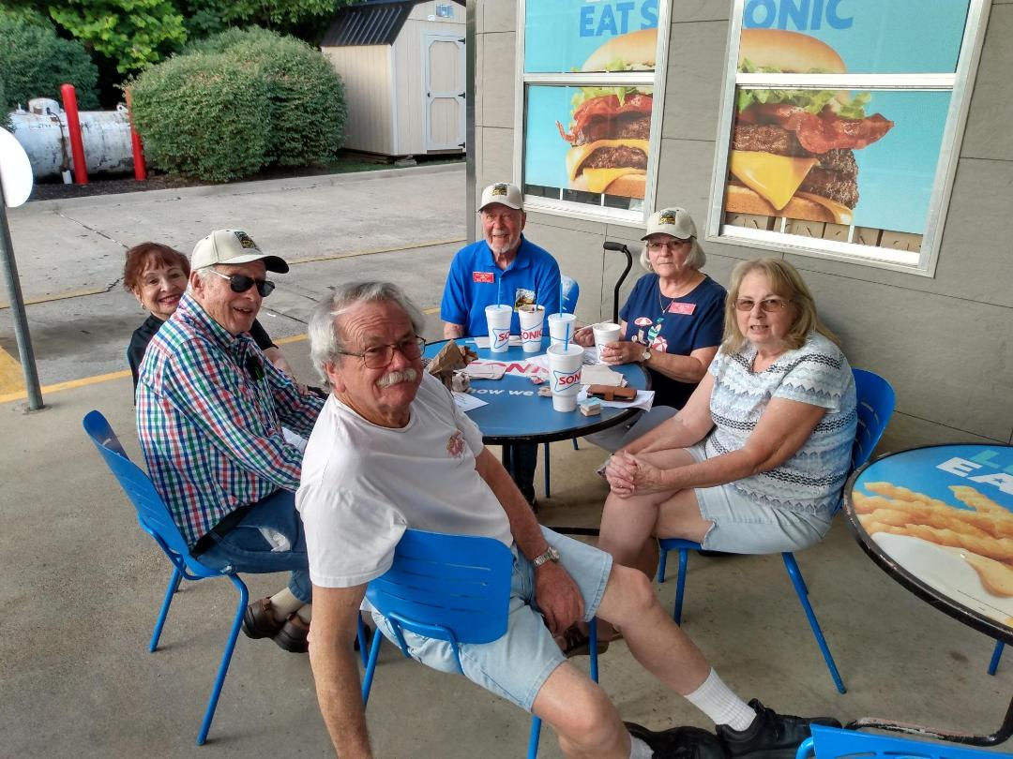
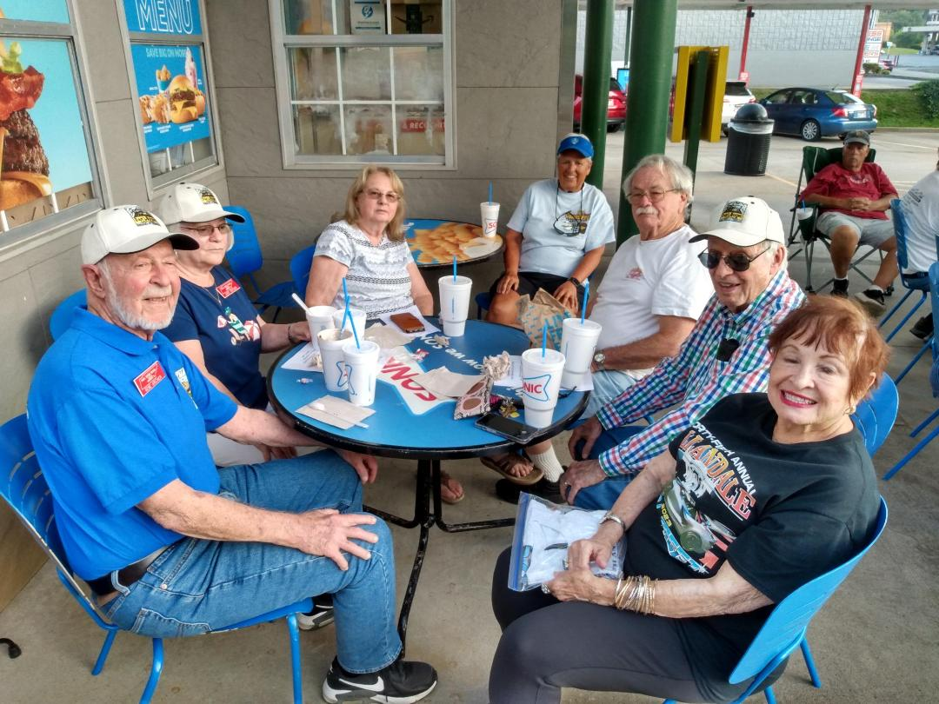
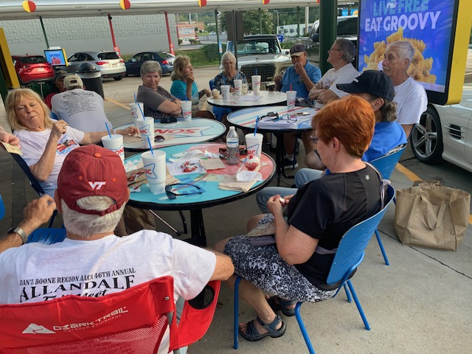
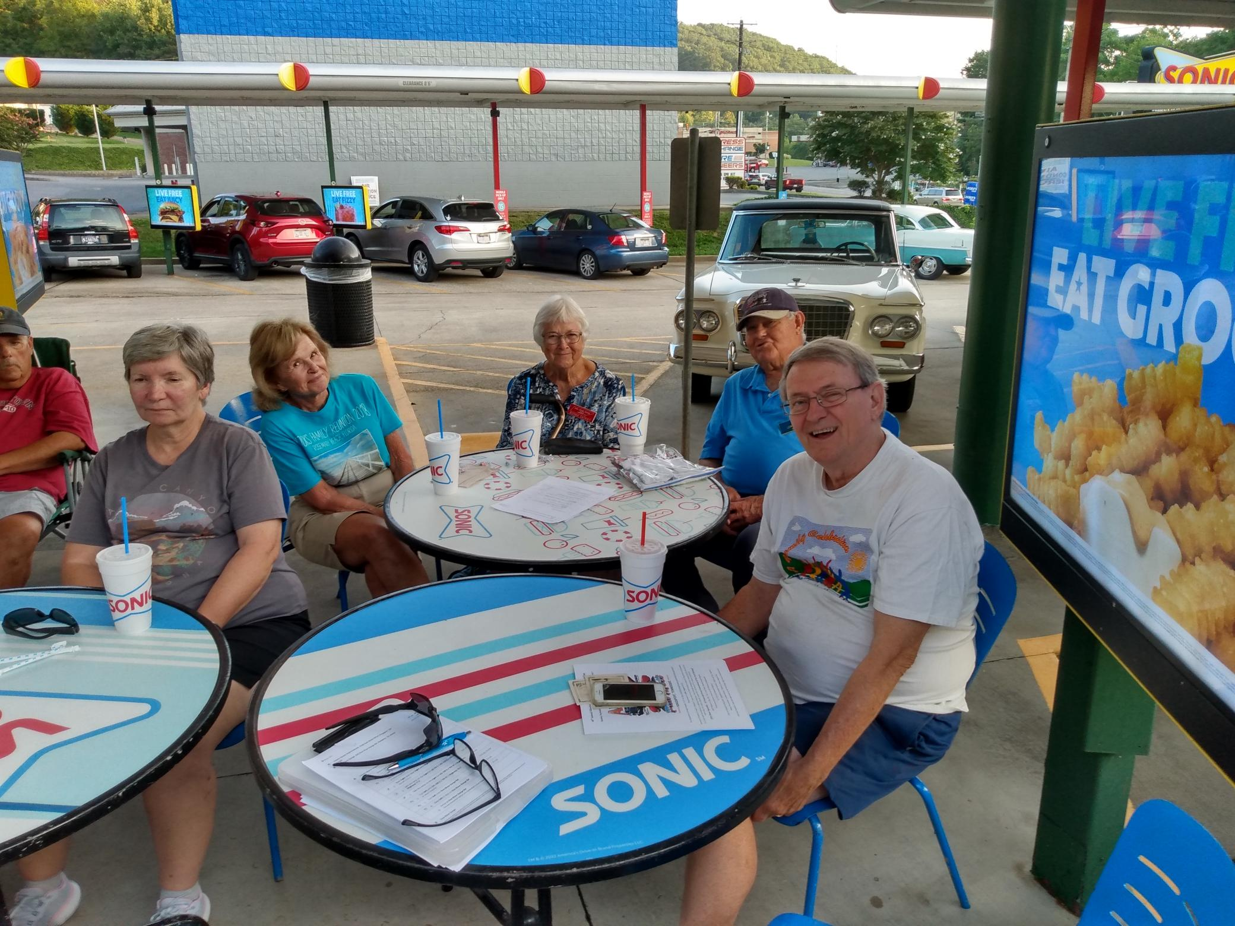
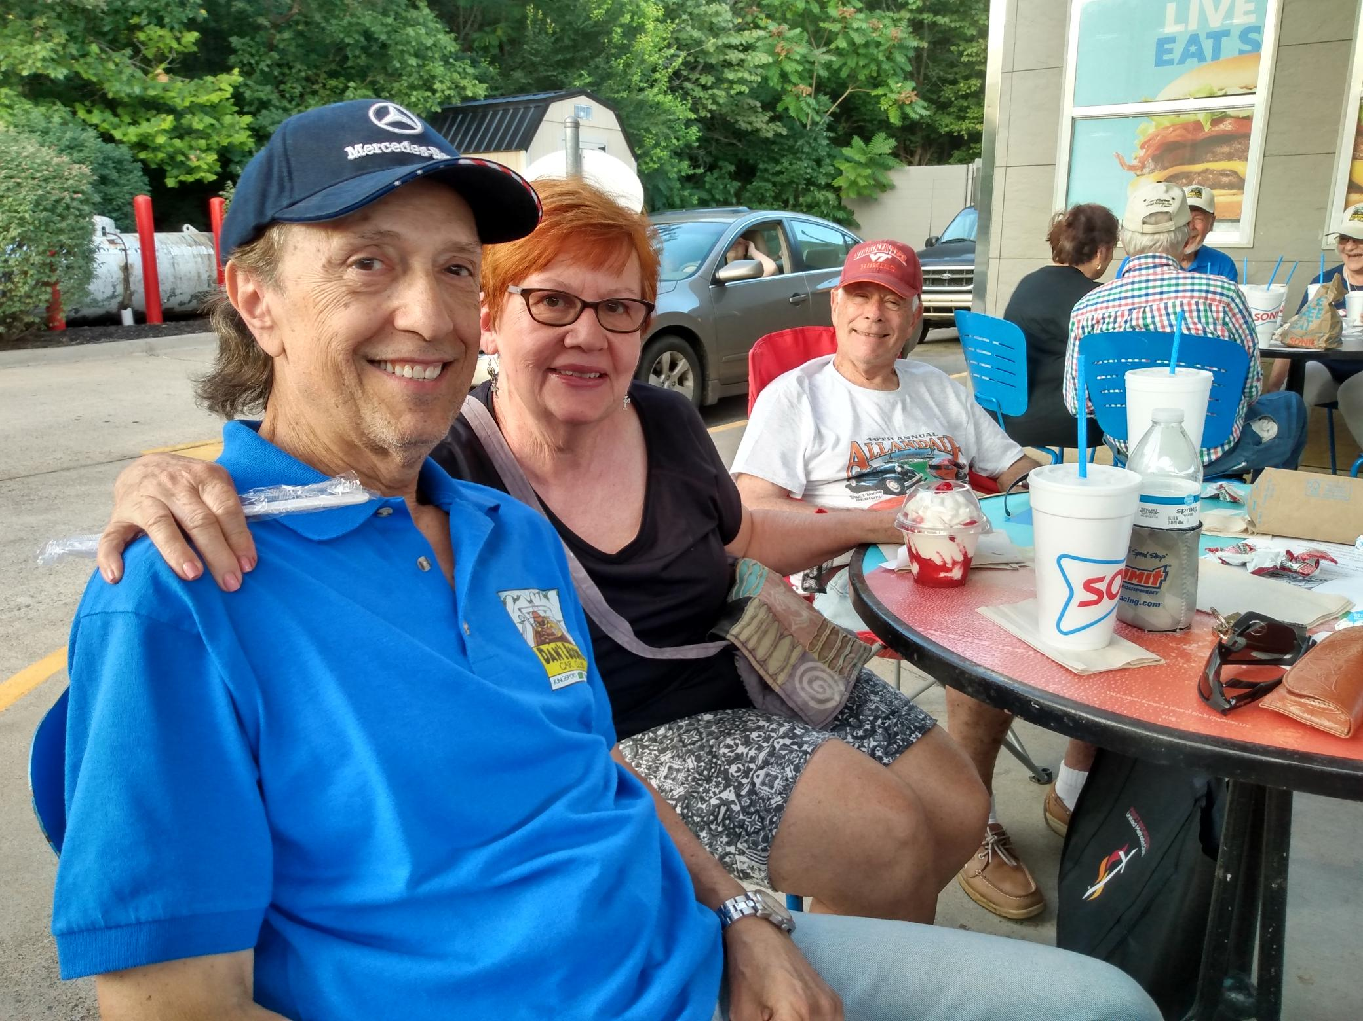

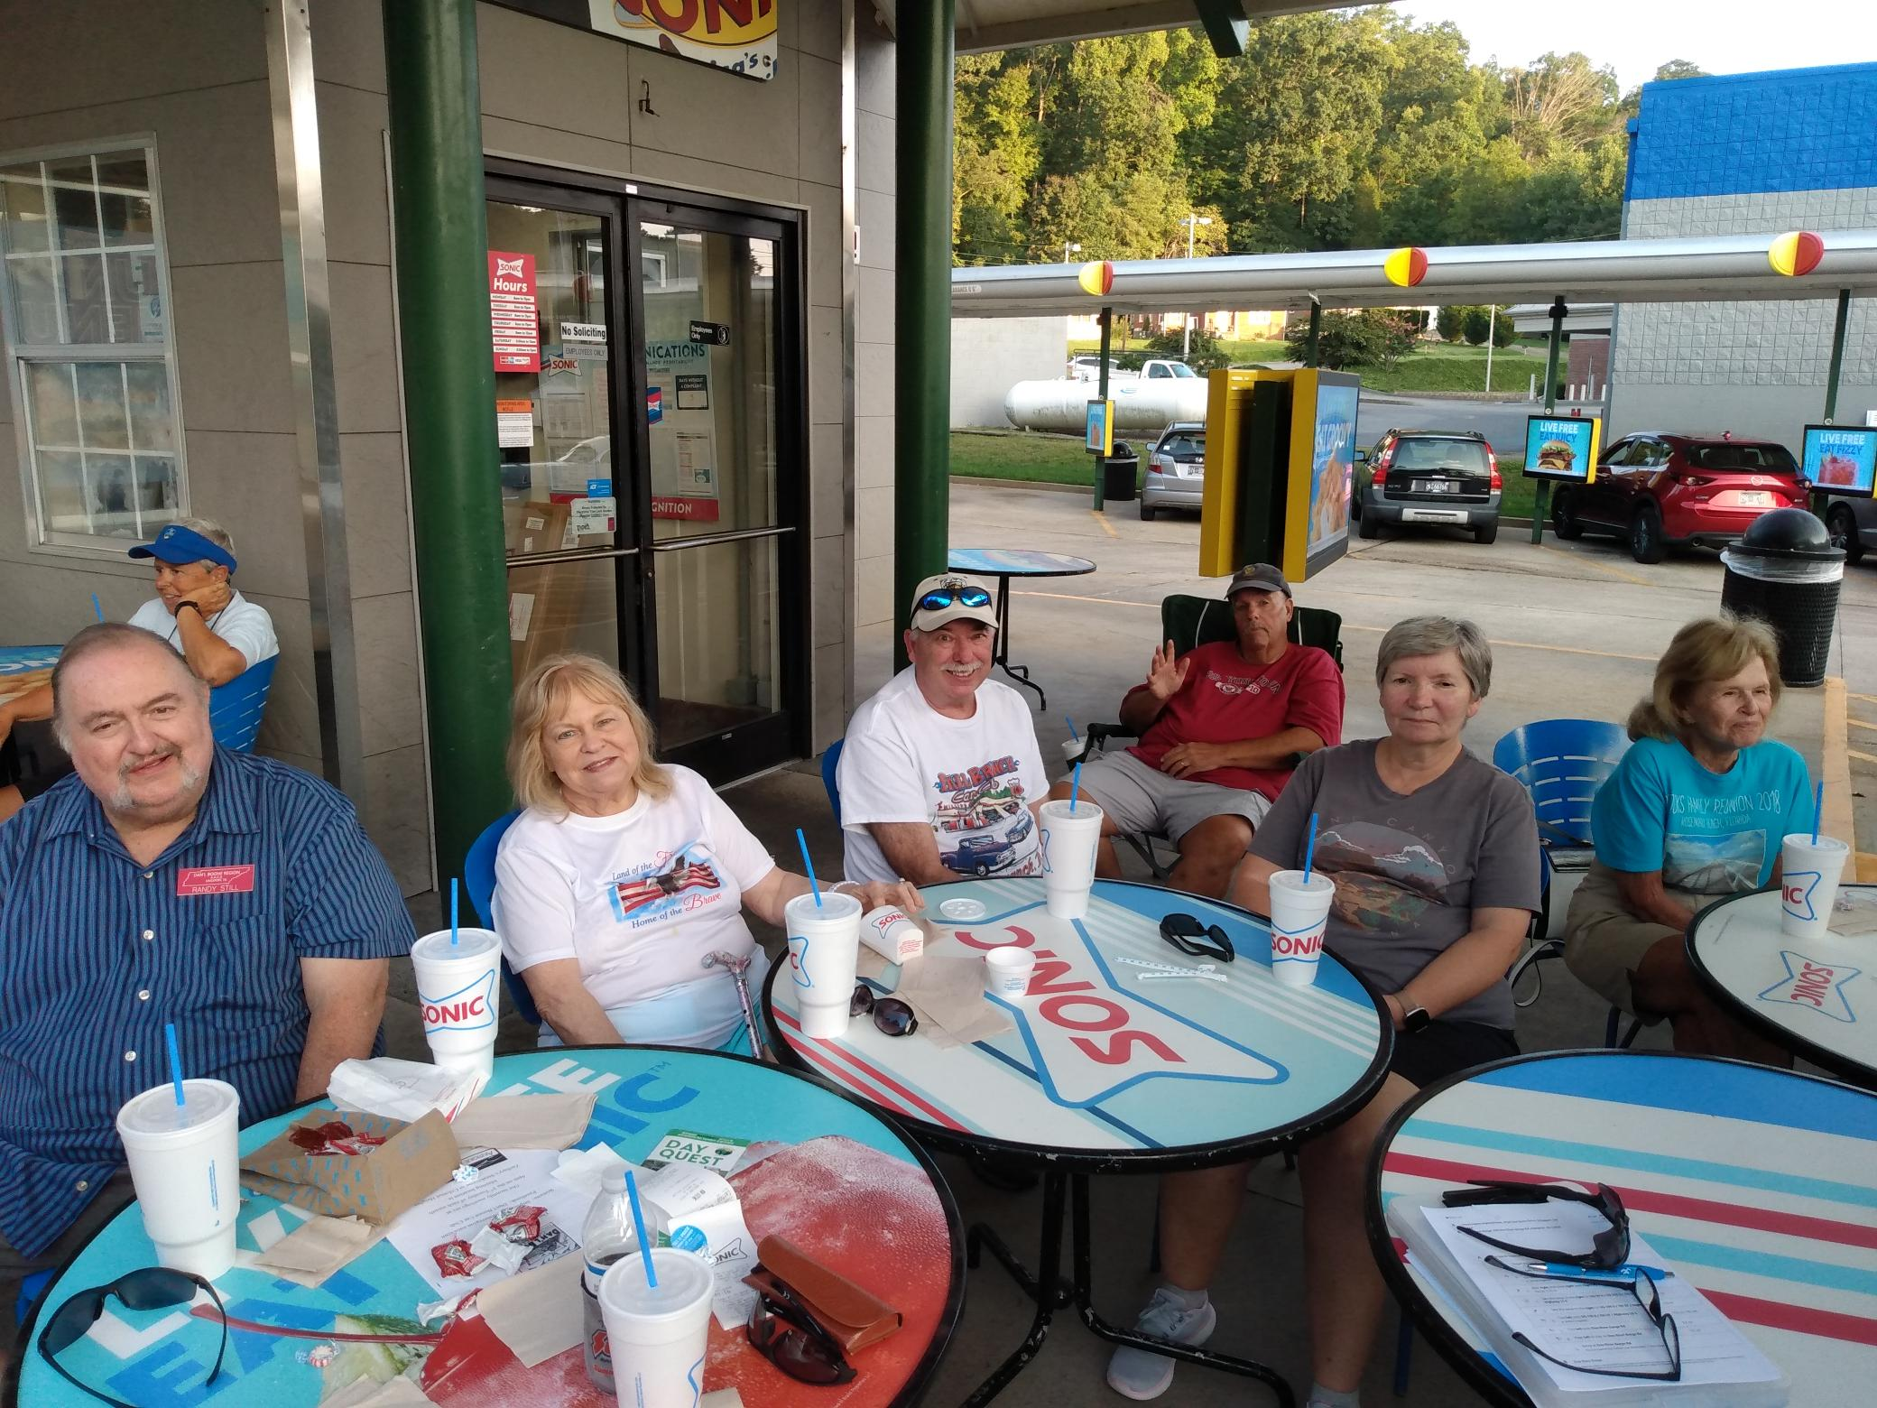
Dan’l Boone Car Club 2024 Event Summary by Month
Including other local events (revision date 9/1/2024)
September
Pharoah’s 4th Annual Fall Car Show, September 1st, 1pm-6pm, 2961 N John B Dennis Hwy, Kpt, TN
Allandale Working session, September 3rd, 6:30pm Lazy Lady Baking Co, 133 N Commerce St, JC, TN
Monthly meeting 6pm Zachary’s Steak House, September 10th
Studebaker, Avanti, Packard Car Show, September 14th, 9am-2pm, 1184 Deerfield Rd., Boone, NC
Allandale Show September 15th
Sonic Cruise in 6pm September 20th
Tri-Cities All Corvette Club Show, 10am-2pm, September 28th Pioneer Chevrolet Abingdon VA
Wings & Wheels on the Greene car show 10am-2pm, September 28th Greeneville Airport
Eddie Laster Memorial Car Show, 10am-4pm, September 29th SW VA Higher Education Center, 1 Partnership Cir, Abingdon, VA
October
Cruise to Cranberry Festival, October 12th, Shady Valley, TN times TBD
Monthly meeting 6pm Zachary’s Steak House, October 15th
Haunted Hot-Rods Car Show, October 19th, 3pm-9pm, Kingsport Farmers Market
Board Meeting TBD
Hershey, PA October 8-11th
Old Dominion Packard Club fall meet Smithfield, VA October 23-27th
November
Monthly meeting 6pm Zachary’s Steak House, November 19th
Cruise to VA Hospital Show for Veterans Day, November 8th ???
December
Monthly Christmas meeting 6pm location TBD, December 17th
A cruise to Johnson City for Moose Club car show, TBD ???
All Aboard, All Aboard, Last Call-ALL ABOARD-PHOTOS BY HOWARD,MATT AND Randy
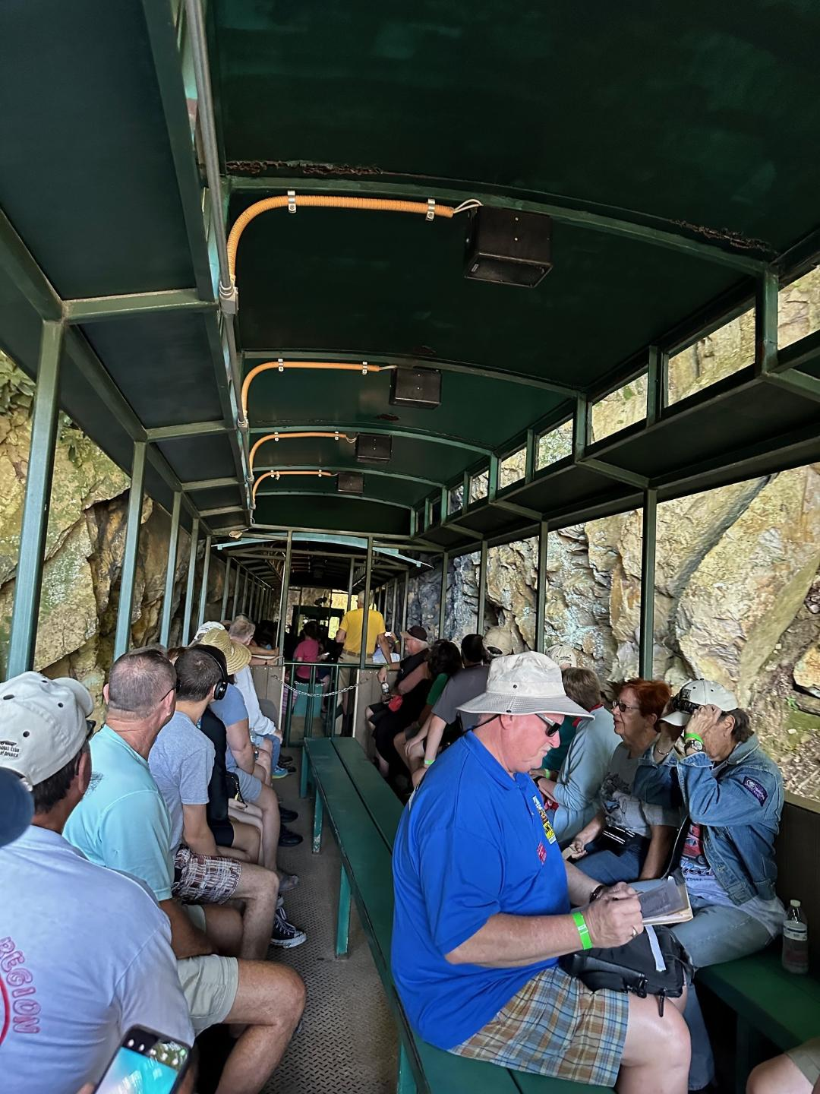
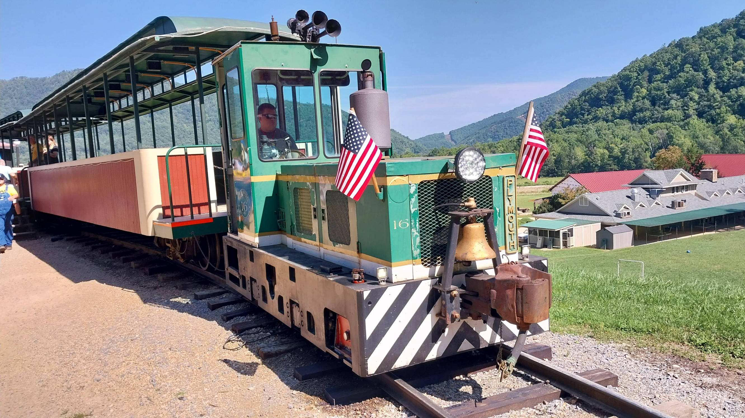
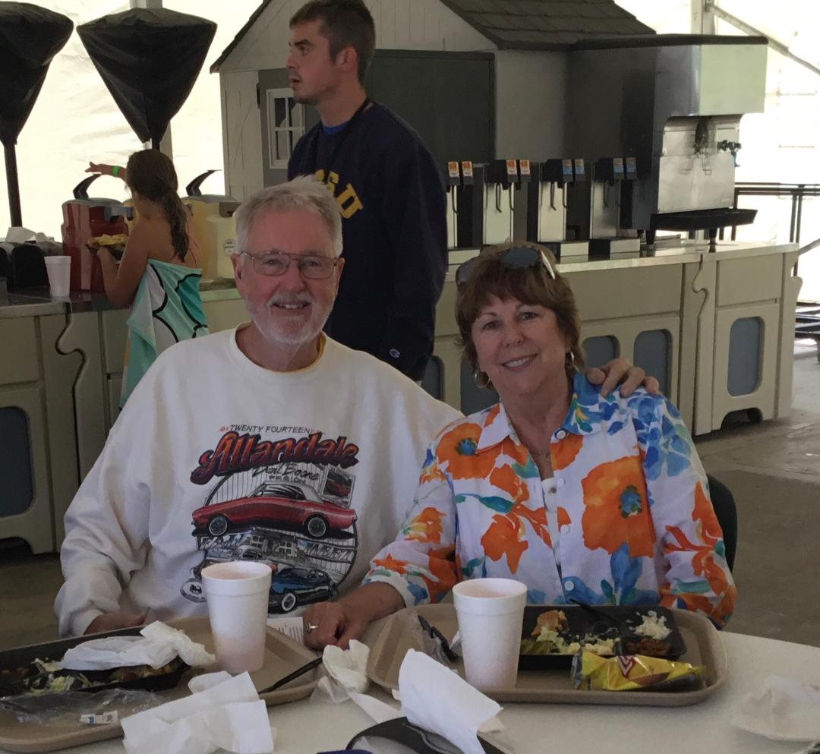
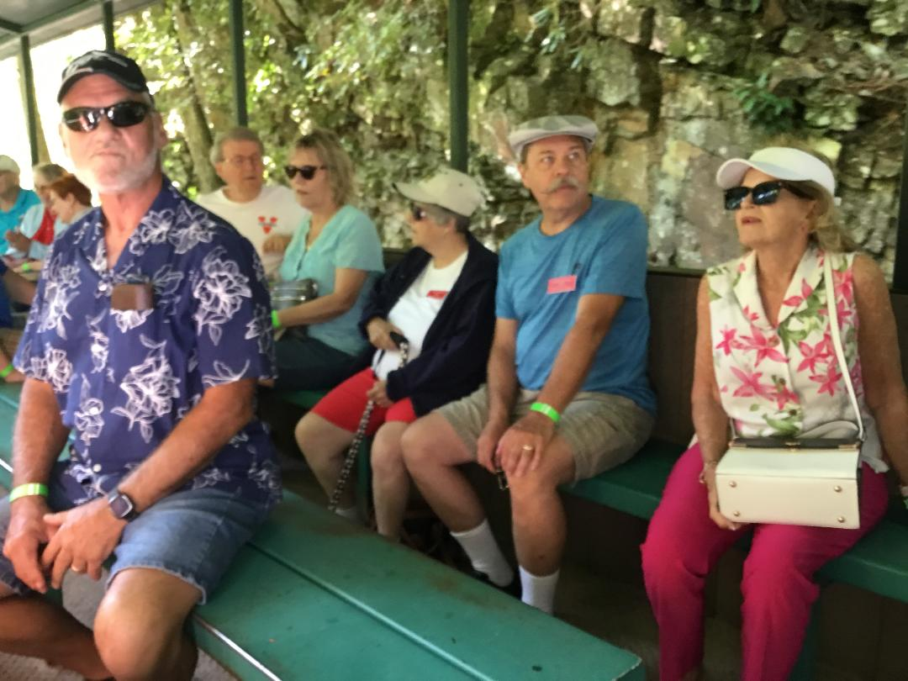

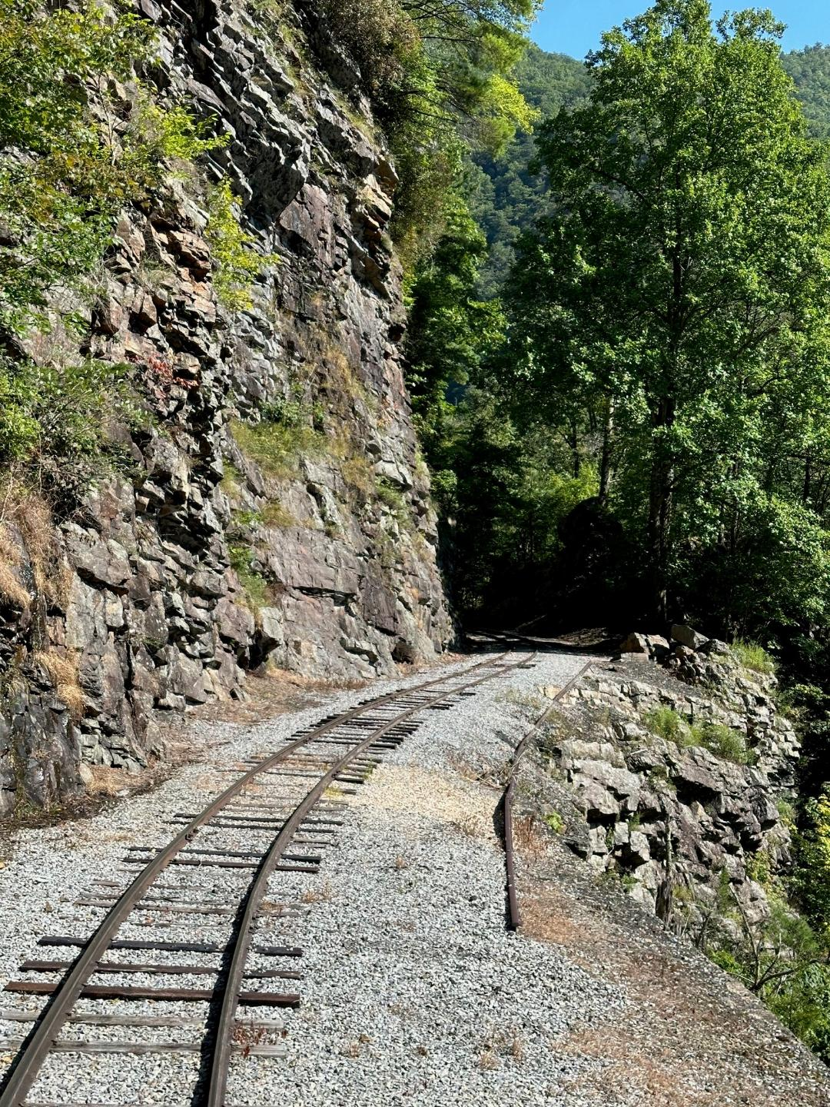
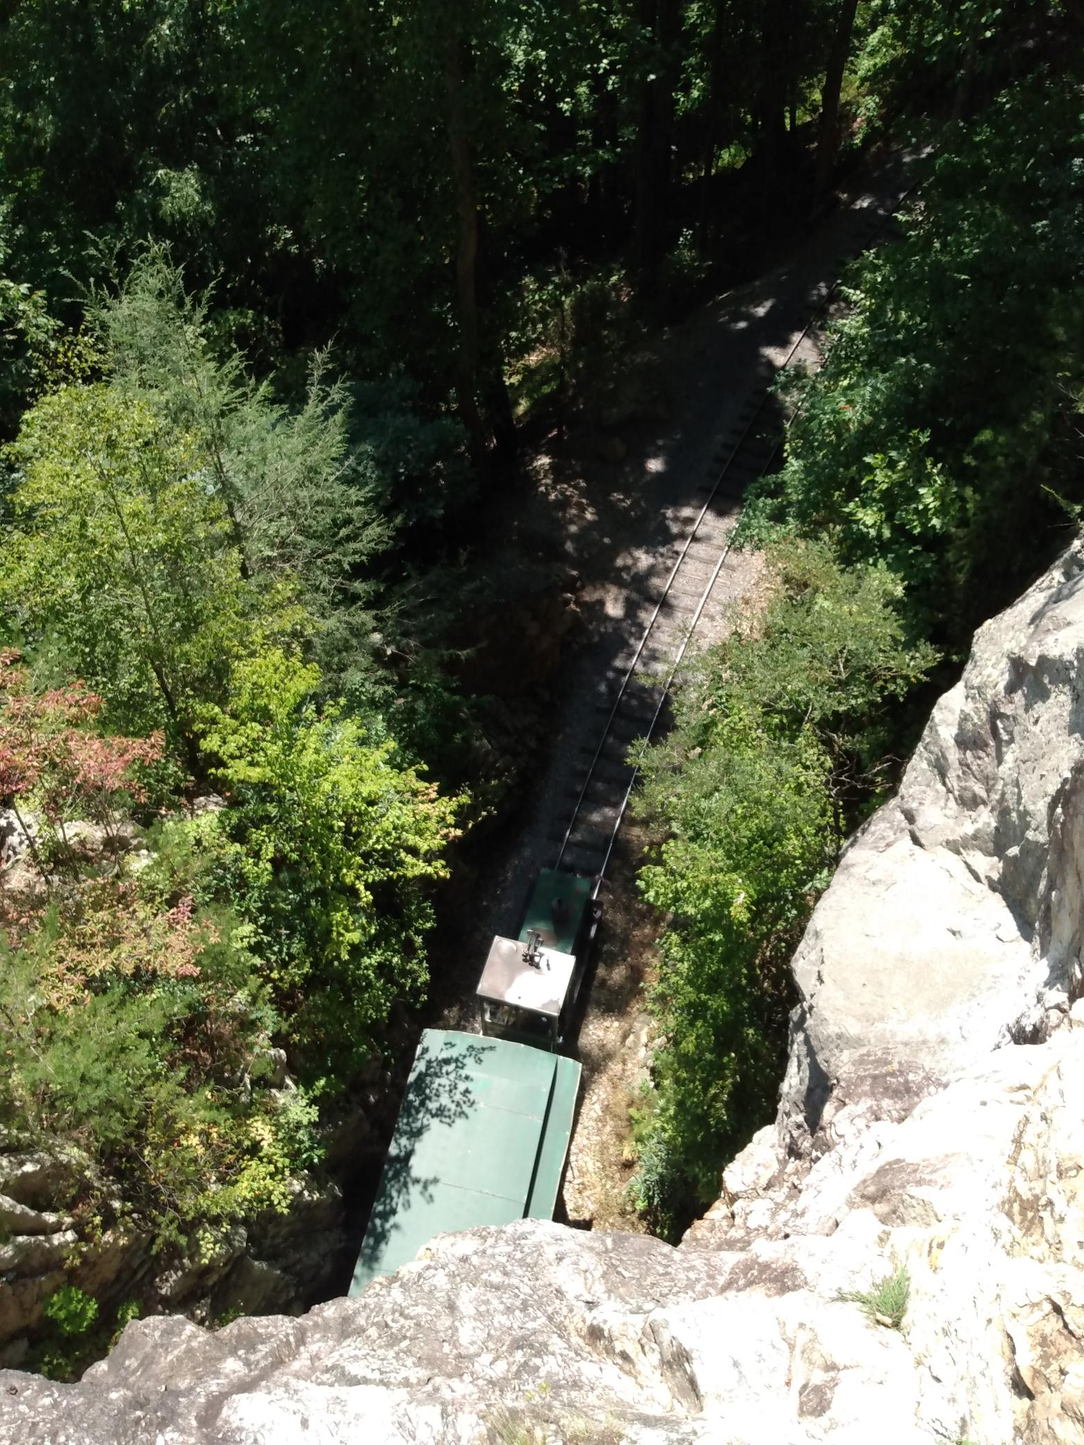

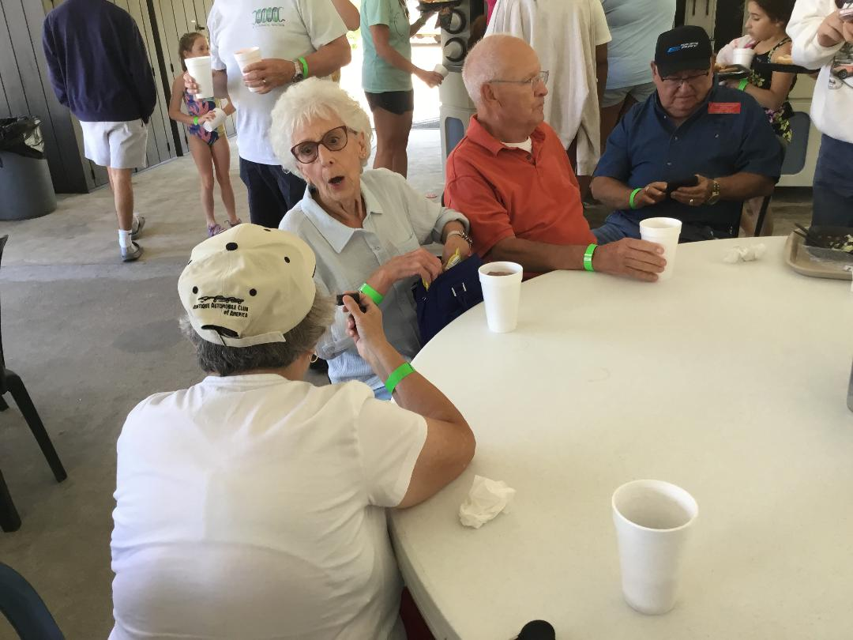
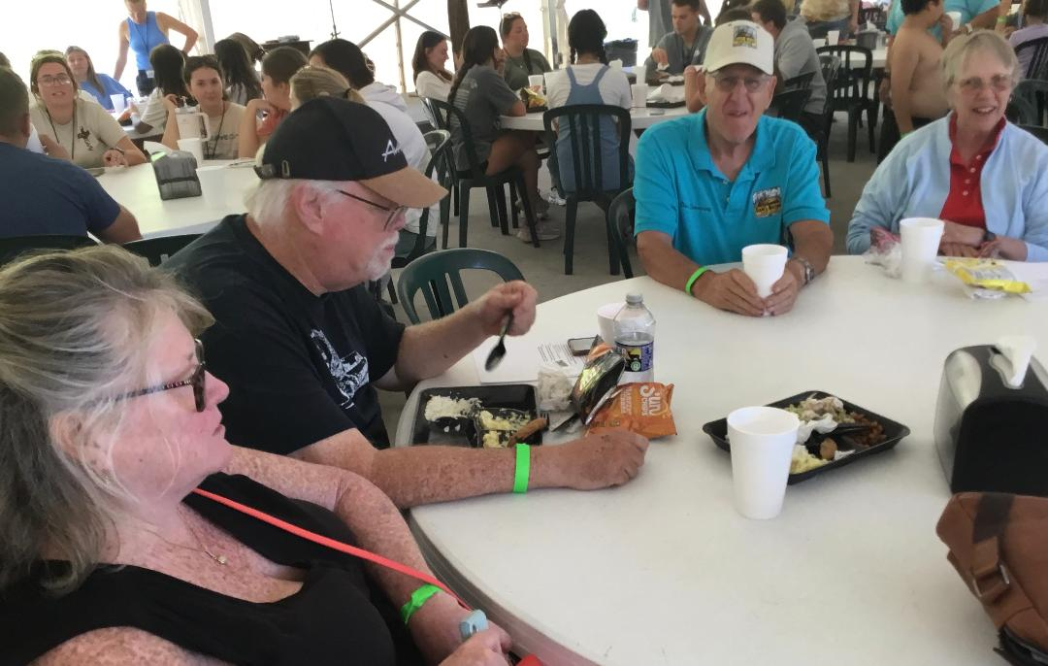
Dining at Doe River Gorge
